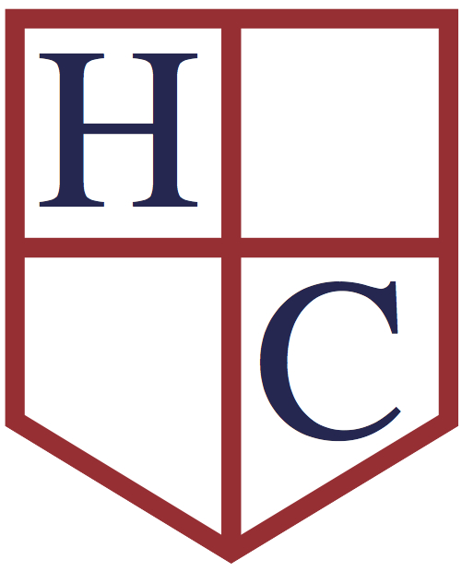
Year: 2
Week beginning: 6th July 2020

Work to be undertaken at home over the course of this week. Each day will consist of one English activity, one Maths activity and other tasks that should be completed during the week.

Teacher’s Instructions:

Hi Year 2! There is not much time left of the summer term now! I hope you are still finding time to complete some on the online tasks before we break up for the holidays.

This week in English we are focusing on reading comprehensions and grammar and in Maths we will be focusing on measuring length and mass (weight). In RE we are thinking about Peter’s escape. In Art we are focusing on self-portraits and in History we are continuing our Victorians projects. In Science we are continuing our new topic about plants.

What books have you read during the school closure? We’d love to hear which ones you have enjoyed!

Have a great week everyone!

Keep in touch and stay safe,

Mrs. Mole & Mrs. Parr

smole4.209@lgflmail.org sparr52.209@lgflmail.org

Monday | Maths | Today we are going to be looking at measuring length. Click on this link https://whiterosemaths.com/homelearning/year-2/ and scroll to the bottom of the page and open week 9 to watch the video ‘Lesson 1 – Measure length (cms)’ to help you. Complete the sheet. Here are the answers for you to check your work.
 | English | Watch the video to see this week’s spellings and today’s comprehensions ‘Queen Victoria’s Diary’ and ‘The Little Factory Girl’.
 | Physical Activity | Let’s practise for own Home Sports Day!!! Today practise the dressing up race. Lay out three items of clothes like a hat, glasses, skirt, shirt etc. Run to each item, put them on in order and run back. Who is the winner? If you are playing on your own, can you do it quicker the next time?
 | RE | Read about Peter’s escape from prison! Make a story board to explain what happened. Draw pictures and write the story.
Tuesday | Maths | Today we are going to be comparing lengths. Click on this link https://whiterosemaths.com/homelearning/year-2/ and scroll to the bottom of the page and open week 9 to watch the video ‘Lesson 2 – Compare lengths’ to help you. Please complete this sheet. Here are the answers for you to check your work.
 | English | Watch the video and complete the 60 second read ‘Victorian Toys’ and ‘Rocket Railway Race’. If you would like a challenge, you can also complete the Summer comprehension.
 | Physical Activity | We are continuing with our Sports Day – the Obstacle race – set up a few things to in your race – you can design it how you like, depending on what you have. You may use a bouncy ball that you have to bounce three times, then a small ball that you have to throw and catch three times, then set up cones or bowls that you have to run around and then finally do ten star jumps before you run back!
 | History | Continue with your Victorians project! You could include:  - Victorian art  - Life for Victorian children  - Rich and poor  - Victorian jobs  - Victorian houses  - Famous Victorians  - Queen Victoria  - Victorian schools  - Victorian clothing  Or any other areas you find interesting!  You can include writing, drawings and pictures you’ve printed. Don’t forget to send an email during or at the end of your projects.
Wednesday | Maths | Today we are going to be looking at the four operations and length. Click on this link https://whiterosemaths.com/homelearning/year-2/ and scroll to the bottom of the page and open week 9 to watch the video ‘Lesson 3 – Four operations with length’ to help you. Please complete this sheet. Here are the answers for you to check your work.
 | English | Watch today’s video. Complete the first two tasks in the Transition Booklet, ‘I am an Amazing Person’ and ‘SPaG activities’.
 | Physical Activity | Sports day – Skipping race. If you don’t have a skipping rope, perhaps you could use a pair of mum’s tights!
 | Art | This week, watch this PowerPoint to learn how to draw a self-portrait. Really take your time with sketching.
Thursday | Maths | Today we are going to focus on comparing mass (weight). Click on this link https://whiterosemaths.com/homelearning/year-2/ and scroll to the bottom of the page and open week 9 to watch the video ‘Lesson 4 –Compare mass’ to help you. Please complete this sheet. Here are the answers for you to check your work.
 | English | Watch today’s video. Complete the third and fourth tasks in the Transition Booklet, ‘Jail Break’ and ‘Emoji Phonics Mosaic’.
 | Science | Read through the PowerPoint presentation about wild flowers. Do you recognise any of the flowers? Why don’t you go on a wild flower hunt around your garden or park? Record what you find on this sheet.
 | Physical Activity | Sports day – Object balancing race. Use this poster to help you.
Friday | Maths | Today we are going to review the Maths we have been learning this half term by completing one of the Maths activity mats (pick the level you want to do). The answers are below each sheet for you to check your work.
 | English | Watch today’s video. First it is the spelling test! Good luck!  Complete the next two tasks in the Transition Booklet, ‘Spot Mr Whoops Mistakes’ and the summer word search.  If you like you can make the fortune teller!
 | Physical Activity | Sports day – Underarm throw skills. Use this poster to help you.

