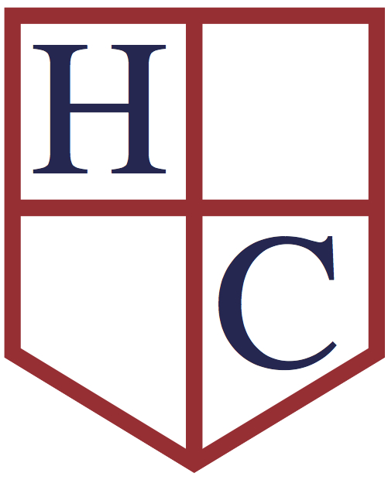
Year: 6
Week beginning: 6.07.2020

Work to be undertaken at home over the course of this week. Each day will consist of one English activity, one Maths activity and other tasks that should be completed during the week.

Teacher’s Instructions:
Bonjour Classe 6,

Only two weeks to go!!! Make them count!

This week in Maths, you will be, focussing on investigations and word problems. An investigation is for you to find a pattern and prove that you are correct by showing examples. For each investigation you need to check and look at the worksheet for tips. You will need all of your mathematical knowledge, common sense, logic and organization skills to solve these… Take your time and make sure you don’t give up on the first hurdle.

I hope you have enjoyed the topic last week. This week, you will be looking at writing stories from different point of views and you will start thinking about starting at your secondary schools. You will be able to reflect on your last year at Holy Cross and how you feel about the year to come. There will be quite a few spellings, reading and writing activities each day, so make sure you read carefully what you have to do.
Don’t forget to do your RE activities…
Have a lovely week, keep in touch and keep safe!

Miss Honoré

Monday | Maths | Mixed Problems – Block 2 worksheet  Revise your times tables.  Redo 10 arithmetic questions from previous tests
 | English | Reading: Read for 30 minutes and do one activity from the ‘Reading Journal Activities’ in your green book.  Spellings: Test 10 words from the list and spellings given since the beginning of the year.  Writing: Photo – Point of view
 | Physical Activity | Joe Wickes 9am on You Tube  or any other physical activities that you enjoy
Tuesday | Maths | Multiply by 11 – Worksheet.  Revise your times tables.  Redo 10 arithmetic questions from previous tests
 | English | Reading: Read for 30 minutes and do one activity from the ‘Reading Journal Activities’ in your green book.  Spellings:  Test 10 words from the list and spellings given since the beginning of the year.  Writing: Write a short well-known story (eg: fairy tale) from two different points of view. You can spread this piece of writing up to tomorrow.  Eg: If you choose to write the Little Red Riding Hood story. You need to write two versions, one from the point of view from Little Red Riding Hood and one from the Wolf.
 | Physical Activity | Joe Wickes 9am on You Tube  Or any other physical activities that you enjoy!
Wednesday | Maths | Wildlife Park Word Problems.  Revise your times tables.  Redo 10 arithmetic questions from previous tests
 | English | Reading: Reading comprehension – ‘The Circulatory Blood System’  This comprehension has 3 levels, Most of you should be doing the 3 stars! Don’t forget to challenge yourself  Spellings: Test 10 words from the list and spellings given since the beginning of the year.  Writing: Finish you two versions of your chosen story.
 | Physical Activity | Joe Wickes 9am on You Tube  Or any other physical activities that you enjoy!
Thursday | Maths | 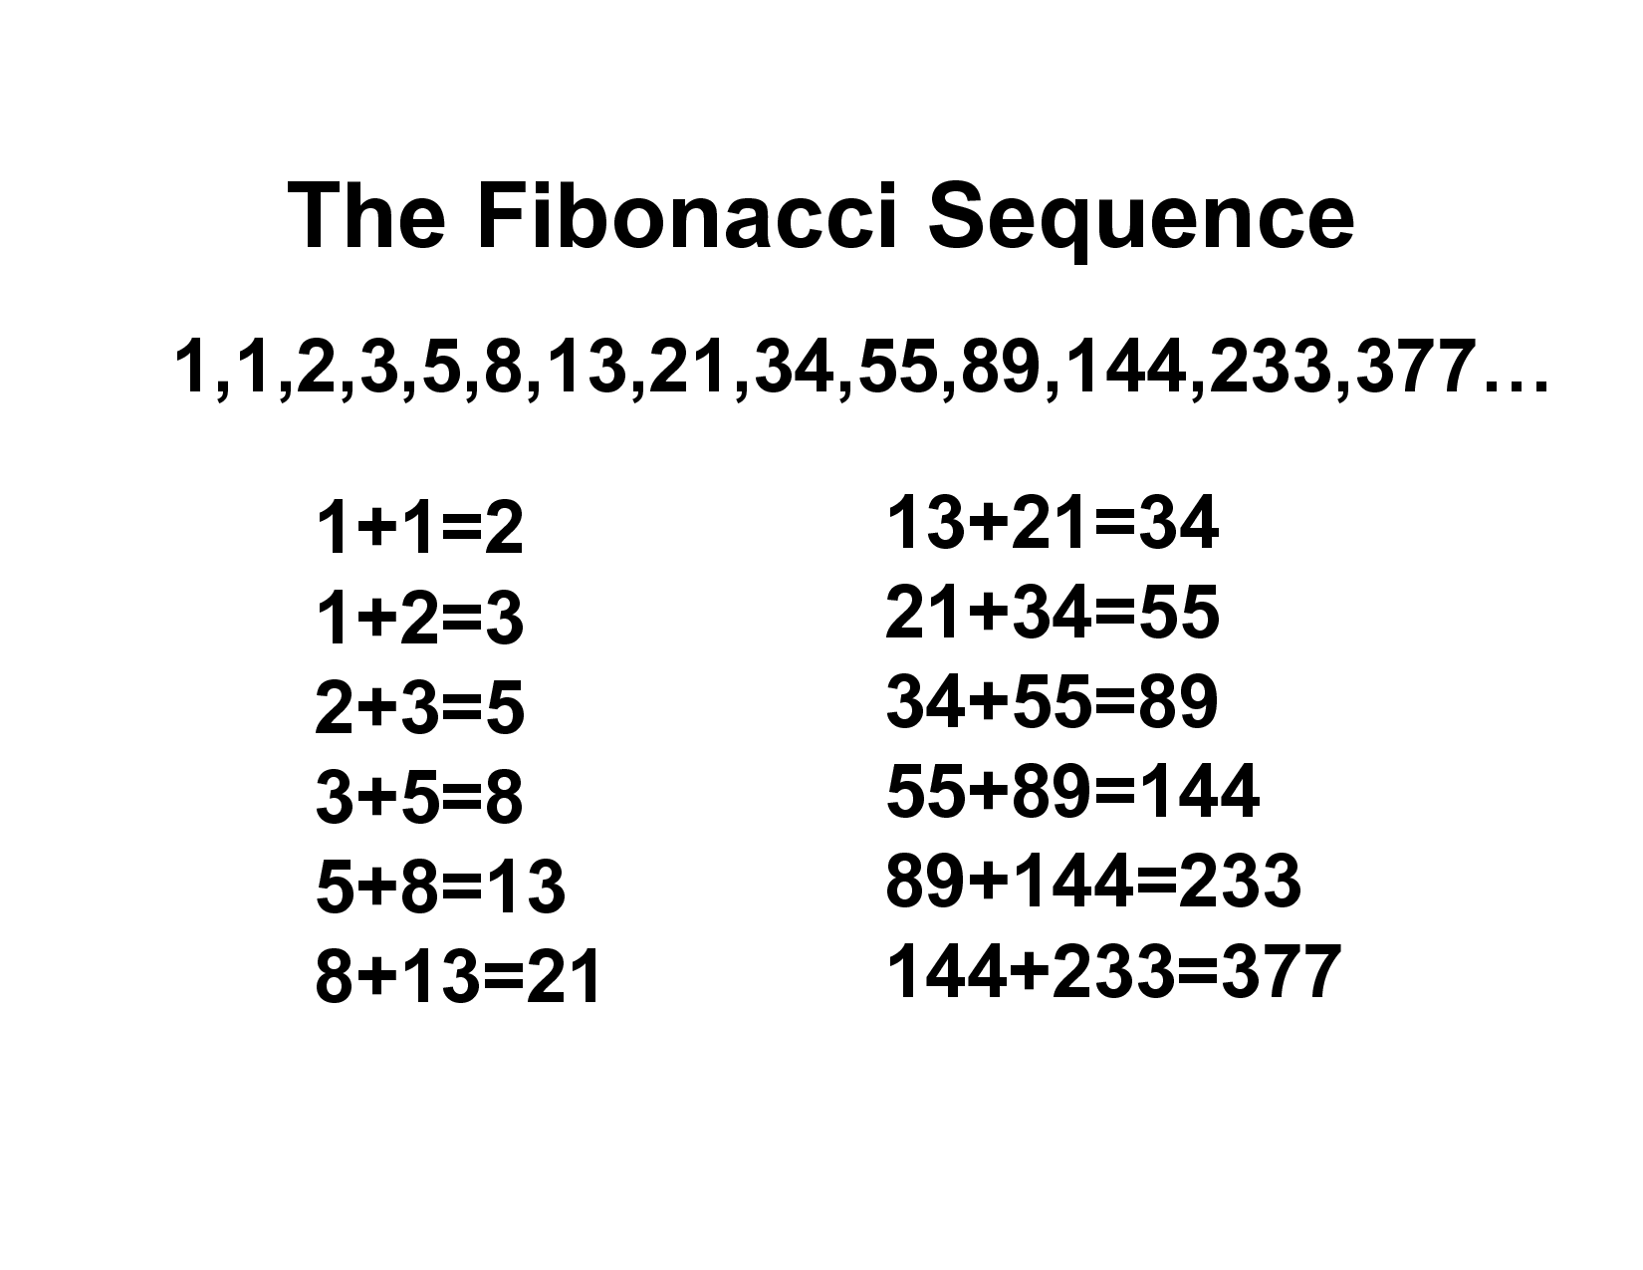  Number Patterns – Worksheet  Tip:  Fibonacci Number:  1,1,2,3,5,8,13…  The sum of the numbers equal to the next number:  Revise your times tables.  Redo 10 arithmetic questions from previous tests
 | English | Reading: Read for 30 minutes and do one activity from the ‘Reading Journal Activities’ in your green book.  Spellings: Test 10 words from the list and spellings given since the beginning of the year.  Writing: Transition Resource for Y6 document. This is a good activity for you to think about your secondary school.
 | Physical Activity | Joe Wickes 9am on You Tube  Or any other physical activities that you enjoy!
Friday | Maths | Word Problem Worksheet 1  Revise your times tables.  Redo 10 arithmetic questions from previous tests
 | English | Reading: Read for 30 minutes and do one activity from the ‘Reading Journal Activities’ in your green book.  Spellings: Test 10 words from the list and spellings given since the beginning of the year.  Writing: Write a letter to your new head teacher. You need to introduce yourself (your family and home situation), tell them what you like to do in class but also in your spare time, what you are good at and what you need help with. What you are looking forward to but also what worries you.  Remember who you are writing to (does it have to be formal) and what sort of writing you are doing (I need to see letter format)!
 | Physical Activity | Joe Wickes 9am on You Tube  Or any other physical activities that you enjoy!

RE: | ‘Resurrection – Keystone and stumbling block This week we are going to know and reflect on the preaching of the Apostles.  Activity 1: Read RE Photo 1  Look at the picture on p76.Imagine you are there with all the people. What questions would you like to ask?  Activity 2: Read RE Photo 2  Imagine you are Peter and you want your message to reach everyone everywhere.  Choose one of those to do:  - Prepare a speech or write an article.  Or  - Write a rap lyric to a song.  Or  - Write an article.  Remember you want everybody to repent and baptised.
Foundation Subjects | Cook with your family, play a game together, draw a picture, create a model or anything else artistic you fancy… Please take pictures and record in your green book.  SUGGESTION: Anything you fancy!!! Have fun!!!

Don’t forget your Purple Mash and Education City activities and check out free websites you can use….

