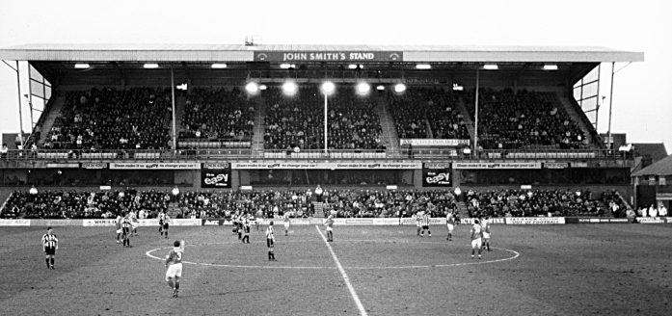

**People in the crowd**

Estimate how many people there are in the crowd.