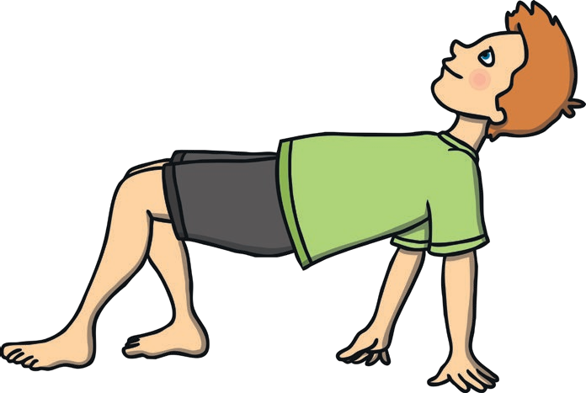
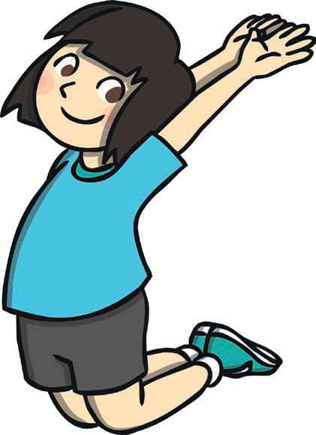

On the roll of a dice, travel around the space in one of the following ways:
- If a one is rolled, jump.
- If two is rolled, hop.
- If three is rolled, skip.
- If four is rolled, gallop.
- If five is rolled, sidestep.
- If six is rolled, choose your own way of moving.

Equipment: a dice
twinkl.com
Roll-a-Movement

Animal Walks

Can you demonstrate these animal movements?
- a frog jumping
- a bunny hopping
- a crab walking
- a monkey walking
- a horse galloping
- a fish swimming
- an elephant stomping
- a cheetah running
- a butterfly flying
- a duck waddling

Can you think of any of more?

twinkl.com

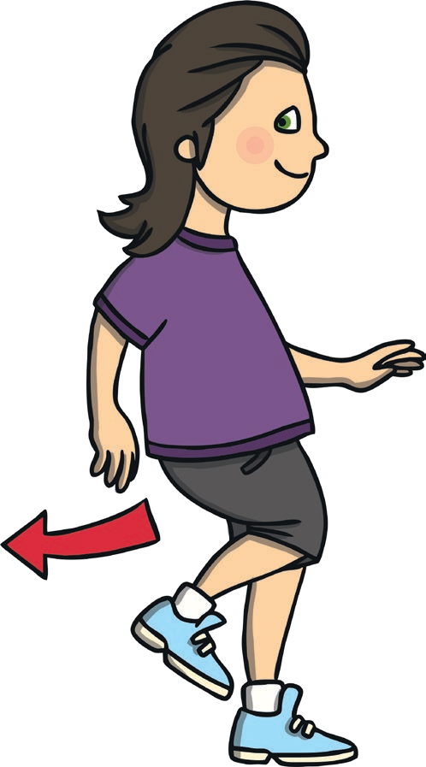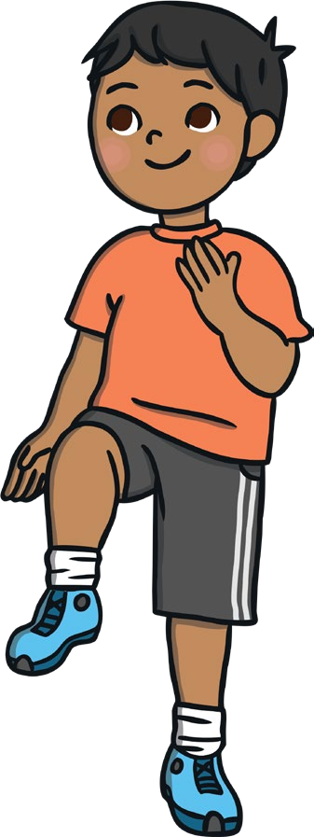

- After a short while, take it in turns to call out the instructions.
Video Game Instructions
- Play – walk
- Fast forward – run
- Rewind – move backwards
- Pause – freeze
- Record – pull a silly face
- Slow motion – move slowly
twinkl.com
Video Games

- Give instructions to your family of what to do. Then swap over and someone else gives the instructions.
- Jump up in the air.
- Hop on one leg.
- Dance your best moves.
- Run on the spot.
- Touch your toes.
- Balance on one leg.
- Do star jumps.
- Squat down.
- Skip on the spot.
- Freeze!
Equipment: hoops
twinkl.com
Hoop Moves

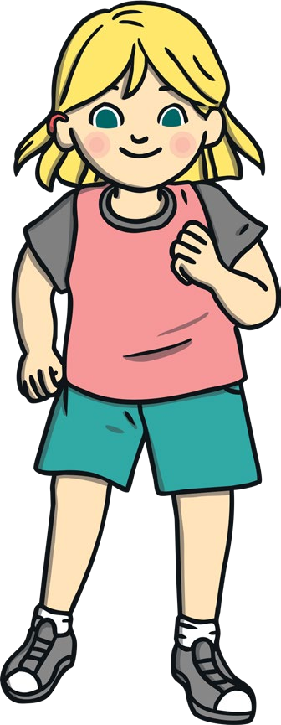
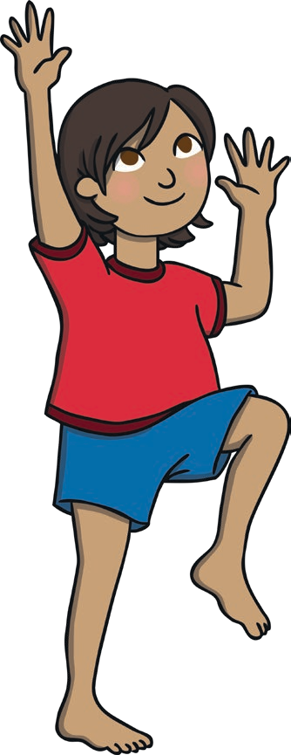

- Listen out for the traffic light instruction as it is called out and move in that way around the space.
- Traffic Light Instructions
- Red – stop
- Amber – jog on the spot
- Green – go
- First gear – walk
- Second gear – jog
- Third gear – sprint
twinkl.com
Traffic Lights

Pirate Ship

  - Follow the pirate command as it is called out.

Pirate Commands
- Climb the rigging! Move your arms and legs up and down as if you are climbing the rigging.
- Captain’s aboard! Stand up straight and salute.
- Scrub the decks! Crouch down
low and pretend to scrub the floor.
- Man overboard! Pretend to swim.
- Dig for treasure! Pretend to dig for treasure.
- Rats on board! Sit on the floor,
hugging your knees into your chest.
- Land ahoy! Put one hand above your eyes as if you have spotted land. Point with the other hand to show your fellow pirates.

twinkl.com

Moving Monsters
Inside Out

- Listen for the names of the Moving Monster and move in the appropriate way, remembering to stay 2m apart.
- Can you think up any Moving Monster of your own?
- Slow Monster – Move slowly around the space.
- Rush Monster – Move quickly around the space.
- Bounce Monster – Jump up and down.
- Muddle Monster – Walk backwards around the space (remember to look where you are going).
- Small Monster – Crouch down and move low to the ground.
- Strong Monster – Stand still and flex your muscles.
Put your hands inside the hoop and keep them in the same position while moving your feet round the outside of the hoop. If you do not have a hoop you can use a some clothing in the shape of a hoop.
- Next, put your feet inside the hoop and keep them in the same position while moving your hands round the outside of the hoop.
- Finally, put one foot inside the hoop and one outside it. Move the outside foot round the hoop. Try to move in a forwards direction and then backwards.

Equiment: hoops

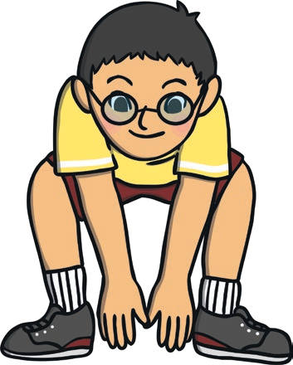
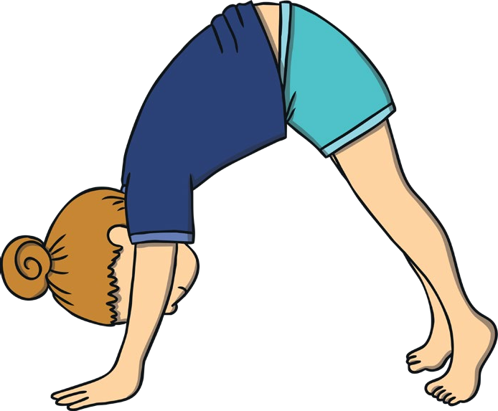

twinkl.com twinkl.com

Jumping Jacks
To the Beat of the Drum

- Carry out the cone command as it is called out. If you do not have a cone use a pair of socks or a cushion.

Cone Commands
- Star jump! Jump in the air and make a star shape.
- Side to side! Jump side to side over the cone.
- Back and forth! Jump forwards and backwards over the cone.
- Hop round! Hop round the cone.
- Hop over! Hop over the cone!
- Hopscotch! Jump and hop next to the cone.

- Someone will need to out a beat, starting fast and getting slower and slower.

Alternative Version
- Stand on the spot,
- Move different body parts or perform different movements to the beat of the drum,
such as running on the spot or doing arm circles.

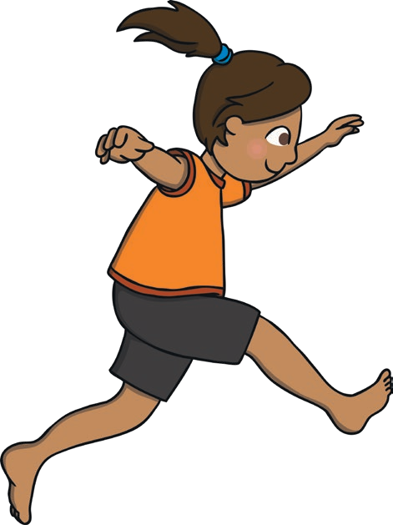
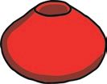

twinkl.com twinkl.com

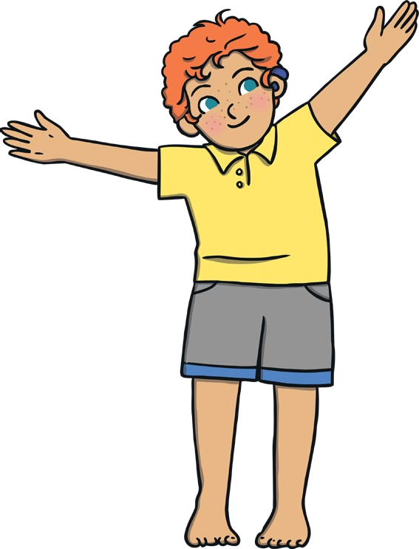
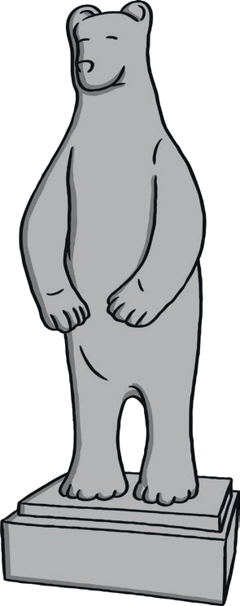
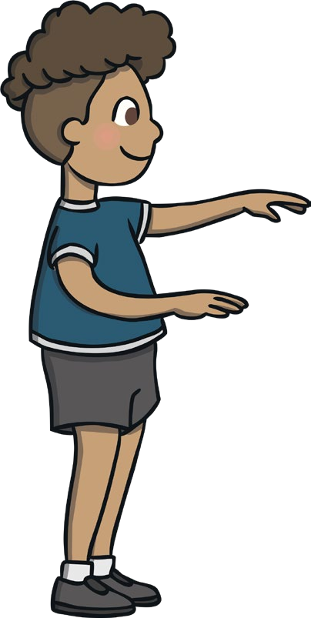

- Move around the space using different movements
while remaining 2m apart.
- When a spell is cast, you will slowly begin to turn to stone.
- Your movements should get slower and heavier until you come to a complete stop and are frozen like a statue.
twinkl.com
Statues

Land the Plane

- You are about to go on a flight!
- Listen to the aeroplane instructions being called and perform the actions.
- Remember to stay 2m apart.

Aeroplane Instructions
- Take off! Walk with your arms stretched out to the side.
- Cruise! Jog around the space.
- Turbulence! Perform little jumps up and down.
- Descend! Slow down your movements to a walk.
- Land! Sit on the floor, arms still out.
- Stop! Place your arms by your side.

twinkl.com

Copycat Dance
Simon Says

- This is a paired activity.
- One will start as the dance instructor and will perform a selection of dance moves.
- Your partner will copy the dance moves.
- The dance instructor should try to use a variety of body parts and movements in their dances.
- After a few minutes, you will swap over roles.

Alternative Version
Perform this as a group all together, with one person chosen as the dance instructor and the rest copying.

- One of you will be chosen to be ‘Simon’.
- ‘Simon’ will say and perform a movement or action, such as, “Simon says do arm circles,” or “Simon says do star jumps.”
- All other players must copy the movement.
- You should not copy the action if the leader does not say, “Simon says…” before the action. If you do, you will perform a forfeit (such as five star jumps).
- Different people will take on the role of ‘Simon’ throughout the game.

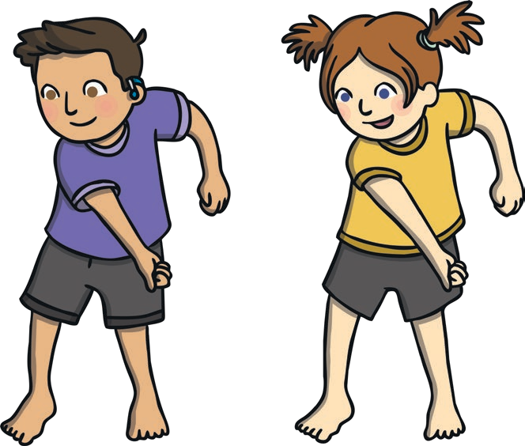
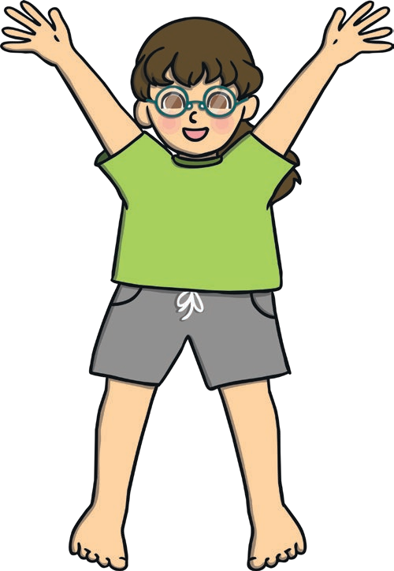

twinkl.com twinkl.com

Fitness Circuit
Jump It!

- When you hear an exercise from the list being called out, you will spend 15 seconds doing that exercise.
- After 15 seconds, walk to the next cone and carry out the next exercise that is called out.

Exercises

- Can you think up any actions of your own?

Instructions
- Kick it! Carefully, kick out in front of you.
- Twist it! Twist the top half of your body at the waist halfway round and then back again, keeping your

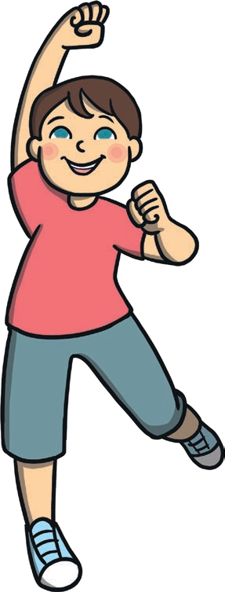
- Star jumps
- Running on the spot
- Lunges
- Punches
- Marching on the spot
- Squats
- Front Kicks
- Running and punching
- Mountain climbers
- Climb the rope
- Frog jumps
- Freestyle dancing
- Knee lifts
- Touch alternate toes
- Own choice

twinkl.com
feet in the same place on the floor. Then repeat, twisting to the other side.
  - Spin it! Turn round in a circle.
  - Pull it! Imagine you are pulling two levers down from above your head.
  - Jump it! Jump as high as you can in the air.

twinkl.com

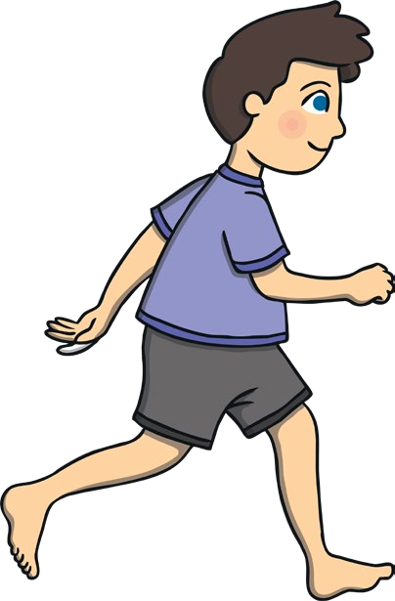
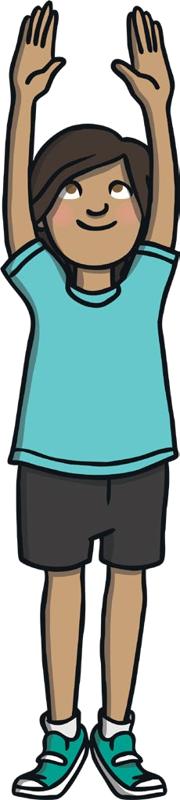

- Move slowly around the space and listen out for the names of different shapes.
- When you hear a shape, jog around the space, tracing a path of that shape. For example, for a square, jog around an imaginary
square-shaped path.

twinkl.com
Making Shapes

Bean Game

    - Move slowly around the space and listen
out for some different ‘bean commands’.

Bean Commands
- Jumping bean – Jump on the spot.
- Runner bean – Run on the spot.
- Broad bean – Stretch your arms and legs out as wide as you can.
- Baked bean – Lay on the floor in a
star shape.
- Jelly bean – Wobble like a jelly.
- Chilli bean – Shiver and shake as if you are cold.
- Frozen bean – Stand still.
- String bean – Stand on your tiptoes and make yourself as tall and thin as possible.
- Kidney bean – Touch your toes.

twinkl.com

Washing Machine
Wacky Walks

- Begin to move slowly around the space, listening out for the washing machine command.

Washing Machine Commands
- Trousers – Stand up straight and as tall as you can.
- Dress – Stand still in a wide stance.
- Socks – Curl up in a ball.

Washing machine – Turn round on the spot.
- Washing line – Flap about as if drying on the line in the breeze.
When instructed you will walk around the space in a wacky walk!
- Listen out for different ways of walking

Wacky Walks
- Walk with big strides.
- Walk with tiny steps.
- Walk backwards – take care!
- Walk sideways.
- Pretend you are walking through heavy mud.
- Imagine you are walking over hot coals.
- Walk slowly and wrap your arms round your body to give yourself a hug.
- Walk and flap your arms like a chicken!

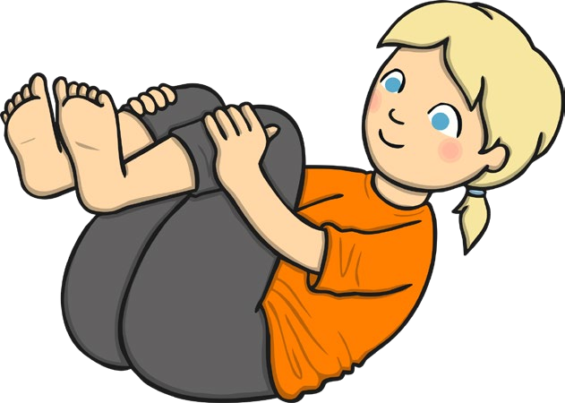
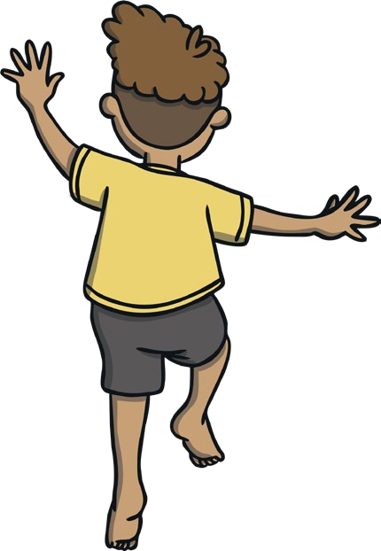

twinkl.com twinkl.com

