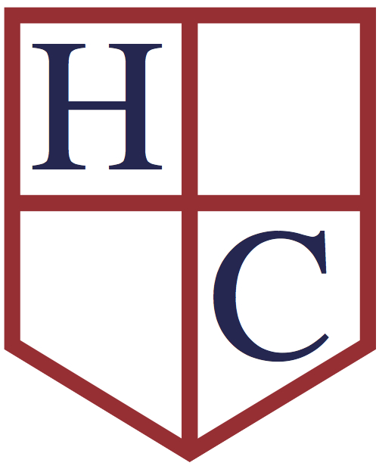
Year: 2
Week beginning: 13th July 2020

Work to be undertaken at home over the course of this week. Each day will consist of one English activity, one Maths activity and other tasks that should be completed during the week.

Teacher’s Instructions:

Hello Year 2! It is the last week of Year 2! It has really flown by with such a strange end to the year. We have missed you all so much. We can’t wait to see you all again in school soon.

This week we are completing end of year activities! We really would love to see your work and read your reflections on the school year! In Maths we will be focusing on investigations. In RE we are thinking about the vocabulary we use in RE. In Art we are finishing our self-portraits and in History we are finishing our Victorians projects. In Science you can choose an experiment to do at home.

We are so proud of the way you have carried on doing your school work at home. This will really help you as you move into Year 3. You are all superstars!

Remember to keep reading every day of the summer holidays! It really is the most important thing you can do. Mums and Dads, please also try to read a bedtime story to your child each night. It is such precious and valuable time with your child.

If you wanted some activities to keep you going over the summer, these might be useful:
- Summer Maths Activity Booklet
- Summer English Activity Booklet
- Summer colouring sheets
- Summer mindfulness colouring sheets
- Summer under the sea colouring
- Summer dot to dot
- Summer word searches

Have a great break everyone! Please keep in touch over the summer; we would still love to receive your emails and photos! We might just not be as quick to reply!
Keep in touch and stay safe,

Mrs. Mole & Mrs. Parr

smole4.209@lgflmail.org sparr52.209@lgflmail.org

Monday | Maths | Today there is the ‘Mystery of the sandcastle stamper investigation’ to choose from (this may take two days to complete) or a simpler 100 square counting investigation.
 | English | Click here for the last set of set 2&3 spellings! We finished set 1 so use these sheets to practise them all as only some will come up in the test on Friday!  As it is the last week of term we thought you might like to think back over your time in Year 2! Complete ‘My School Year Memory Page’! We’d love to see the finished version!
 | Physical Activity | Complete the following Go Noodle activities! Choose one or do both!  https://www.youtube.com/watch?v=7Li2qwdUsxU7  https://www.youtube.com/watch?v=aZru-M3TUlI
 | RE | Can you make an RE glossary? Look at the list of words and explain what they mean.
Tuesday | Maths | If you chose the sandcastle investigation then carry on solving the mystery today. Here are the answers for you to check your work. There is also a simpler coin investigation and the answers are below.
 | English | Can you make a start on the End of School Year Booklet?!
 | Physical Activity | Complete the following dance video activity!  https://www.youtube.com/watch?v=hHNJSMUgWBM
 | History | Have you finished your Victorian’s projects?! Please send photos of what you have done!
Wednesday | Maths | Here is another investigation to solve, ‘The mystery of the Naughty gnome’ (it may take two days to complete). If you want to do something easier play this building block addition and subtraction board game.
 | English | Complete the End of School Year Booklet!
 | Physical Activity | Complete the following dance!  https://www.youtube.com/watch?v=BQ9q4U2P3ig
 | Art | This week you can colour or paint your self-portrait. You can also try to sketch the face of someone in your family.
Thursday | Maths | Carry on with the gnome investigation. The answers are below for you to check your work. If you want to do something different here is a 3D snakes and ladders game you can make and play.
 | English | Complete the A-Z of the school year! What things have you learnt?
 | Physical Activity | Complete the following dance! Choose one or do both!  https://www.youtube.com/watch?v=Imhi98dHa5w  https://www.youtube.com/watch?v=B6v9FOxhzxw&list=RD7jODXRC2V68&index=10
 | Science | Choose from one of the following experiments and have a go at home. Check with your parents first before you carry them out.  Fireworks in a glass  Melt the ice  Dancing raisins  Egg science experiments  I would love to see a photograph of you carrying them out!
Friday | Maths | Go on a weights and measures scavenger hunt around your house or garden. Can you find everything on the sheet?
 | English | Watch the last video. Today is your last spelling test! Good luck! Use today to finish any activities from the week then go online and email us both before we break up for the summer holidays!
 | Physical Activity | Complete the following dance video!  https://www.youtube.com/watch?v=r-7Z1Tg_Sbw

