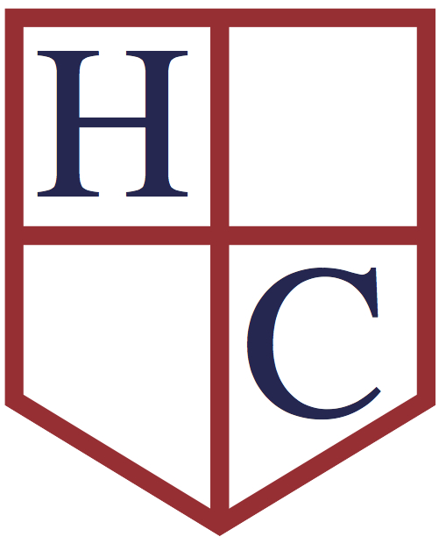
Year: Year 4
Week beginning: 13.7.20

Work to be undertaken at home over the course of this week. Each day will consist of one English activity, one Maths activity and other tasks that should be completed during the week.
Marvellous Year 4,

You have made it! What an unusual academic year you have had! You have worked so hard and made yourself proud! Thank you for all your dedication and fantastic messages that kept me going. I dearly missed you.

This week, I have prepared some fun investigations in Maths. In English, you will get to read the rest of ‘The Story of Tutankhamun’, write and make your own book based on it. You will also complete a spelling quiz of statutory words on Purple Mash. Moreover, you will explore The Communion of Saints in RE. In addition, you will be able to complete a non-fiction book project about Ancient Egypt. Finally, you will have an opportunity to complete some fun Science experiments.

Throughout the summer, you can still use Purple Mash, Education City, First News ihub and BBC Bitesize to play various educational games, especially for times tables and spellings.

As usual, I linked all the Resources to One Drive documents. If you have One Drive installed on your device, you only need to CTRL+ CLICK on the underlined link and the attachment will open.

Over the summer break, do not forget to pray with your families and ask God for our safe return in Autumn term.

I would like to take this opportunity to thank all the parent and carers for continuous support and hard work during these unprecedented times. You have been absolutely stunning and have done an amazing job! Thank you very much!

Have a safe and adventurous Summer and come back all well and sound in Autumn term!
I cannot wait to see you!

Loads of love!

Miss Stojek

Monday | Maths |  | Read and complete ‘Monday Investigations’.
 | English |  | Read ‘Story of Tutankhamun p.32-41’. What happened in the story so far? How did the characters feel? Did you find anything surprising? What was it? Make a multiple-choice questionnaire about Howard’s Carter discovery.  Today, you are going to try and complete a spelling quiz from the statutory words. Check Purple Mash and complete Quiz 1 that I have set up for you.
 | Physical Activity |  | Create a Physical Activity of your choice. Could you make it around Ancient Egyptian topic? Complete breathing exercise - ‘Pharaoh’- to cool down.
Tuesday | Maths |  | Read and complete ‘Tuesday Investigations’.
 | English |  | Read ‘Story of Tutankhamun p.42-46 and p. 47-60’.  What happened in the story so far? How did the characters feel? Did you find anything surprising? What was it?  This week, I would like you to create your own story about Howard Carter or Pharaoh Tutankhamun. It can be a narrative (Written in paragraphs, like a chapter book) or a comic strip. It can also be a mixture of both. Start planning your story today. Use a mind-map or story map technique to gather all your ideas, such as characters, events or plot.  ‘The Story of Tutankhamun’ by Patricia Cleveland Peck is a non-fiction story. It means that all the information included in the book are true. Your story can be also a non-fiction book, but be careful! You must include facts that can be proven by historical research. Or it can be a fiction story- you can get inspired by the historical characters such as Howard Carter or Tutankhamun and invent some adventures that they have experienced, not necessarily true.  Remember, a good fiction story always has 3 main parts:  1. Introduction- where characters and settings are introduced. 2. Problem- where you introduce a difficultly or a problem that the main character is struggling with. 3. Resolution- where you describe the quest of your character and explain how they overcame the problem. Good luck with your mind-map or story map!  Today, you are also going to try and complete a spelling quiz from the statutory words. Check Purple Mash and complete Quiz 2 that I have set up for you.
 | Physical Activity |  | Create a Physical Activity of your choice. Could you make it around Ancient Egyptian topic? Complete breathing exercise - ‘Pharaoh’- to cool down.
Wednesday | Maths |  | Read and complete ‘Wednesday Investigations’.
 | English |  | Read ‘Story of Tutankhamun p.61-64’. What happened in the story so far? How did the characters feel? Did you find anything surprising? What was it?  Start writing your story. Use the mind-map/ story map from yesterday. Remember, the book should be focused on the Ancient Egypt and either Pharaoh Tutankhamun or Howard Carter. Good luck! You will also have Thursday to finish it off, and finally make it into a book on Friday! Take your time. Use the best vocabulary you can think of.  Today, you are also going to try and complete a spelling quiz from the statutory words. Check Purple Mash and complete Quiz 3 that I have set up for you.
 | Physical Activity |  | Create a Physical Activity of your choice. Could you make it around Ancient Egyptian topic? Complete breathing exercise - ‘Pharaoh’- to cool down.
Thursday | Maths |  | Read and complete ‘Thursday Investigations’.
 | English |  | Continue working on your book that you have started on Wednesday.  Today, you are also going to try and complete a spelling quiz from the statutory words. Check Purple Mash and complete Quiz 4 that I have set up for you.
 | Physical Activity |  | Create a Physical Activity of your choice. Could you make it around Ancient Egyptian topic? Complete breathing exercise - ‘Pharaoh’- to cool down.
Friday | Maths | Read and complete ‘Friday Investigations’.
 | English | Edit the draft of your book from previous sessions. Have you included all the features? Are you spelling and punctuation correct?  Copy neatly your story and illustrate it. Make it into a book.  Today, you are also going to try and complete a spelling quiz from the statutory words. Check Purple Mash and complete Quiz 4 that I have set up for you.
 | Physical Activity | Create a Physical Activity of your choice. Could you make it around Ancient Egyptian topic? Complete breathing exercise - ‘Pharaoh’- to cool down.

RE: | Read about ‘The Communion of Saints’. Look at the picture. How do you think it illustrates the Communion of Saints? Make your own illustration/painting of The Communion of Saints. Write an explanation for it. Choose a Saint and either make a guide about their life and mission or draw a portrait and add information about their life. How Saints could help you? Could you become a saint? How? Finally, write a prayer to thank God for all the saints who guide us in our daily lives.
Foundation Subjects:  History | Reflect: What was your favourite part of the Ancient Egyptian topic? Mine was mummification and pyramids. Was there anything that surprised you? Puzzled you? What was it? Did any of the information remind you of something? Was it a story? A country you read about or visited?  Understand: Click here to check more interesting facts about Ancient Egypt. Are there any areas of the topic that we have not studied? Find out about it.  Challenge: Look at the ‘Ancient Egypt Flipbook’, it is a non-chronological report about Ancient Egypt. You can either make your own non-fiction book about Ancient Egypt or make some more art and craft projects to do with Ancient Egypt. It is up to you.  For non-chronological report. Check ‘Ancient Egypt Flipbook’.  For Art and DT projects check ‘Egyptian Things To Make and Do’.
Science | You have been great scientist this year, Year 4! Well done! You have always been extremely eager about all investigations and experiments. Look at the ‘End of Year Experiments’ that I have prepared for you. Choose some of them and complete at home. Read the instructions carefully. Always try to use recycled materials.  If the experiment involves heating something up or baking ALWAYS ASK YOUR ADULT to SUPERVISE YOU!!!  Good luck and enjoy!

