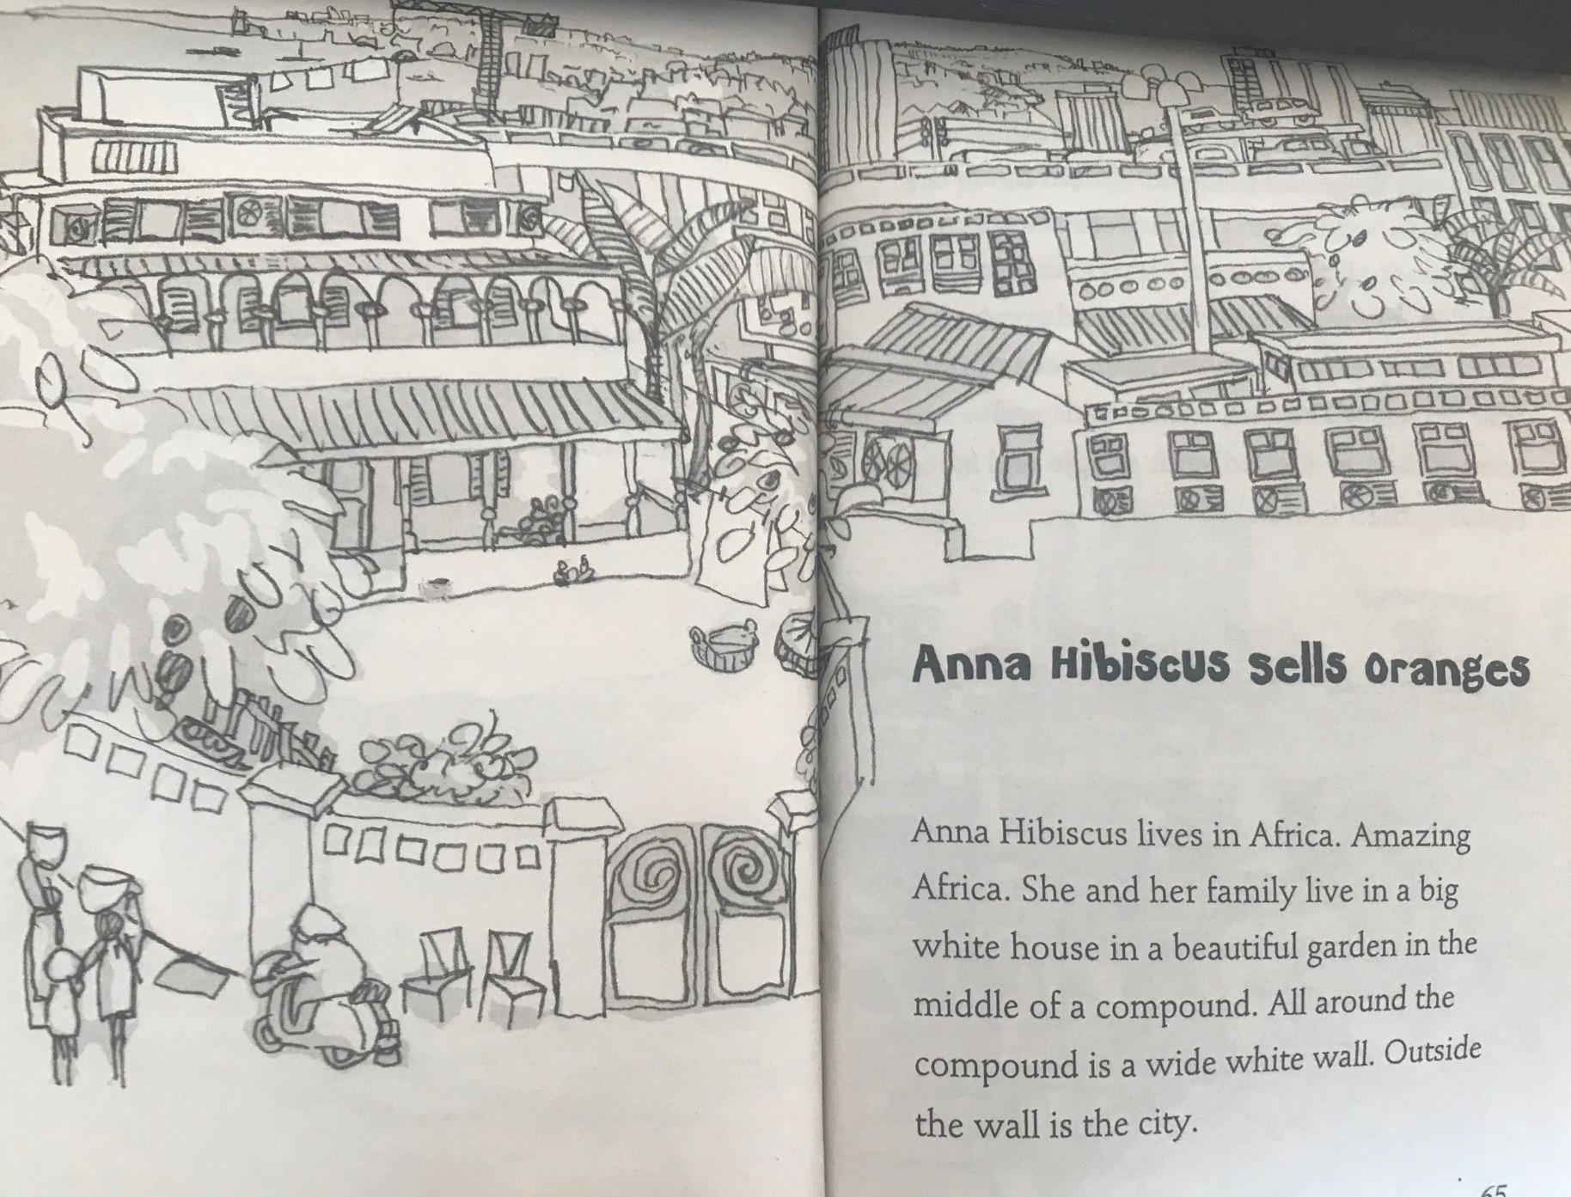
Anna Hibiscus Sells Oranges
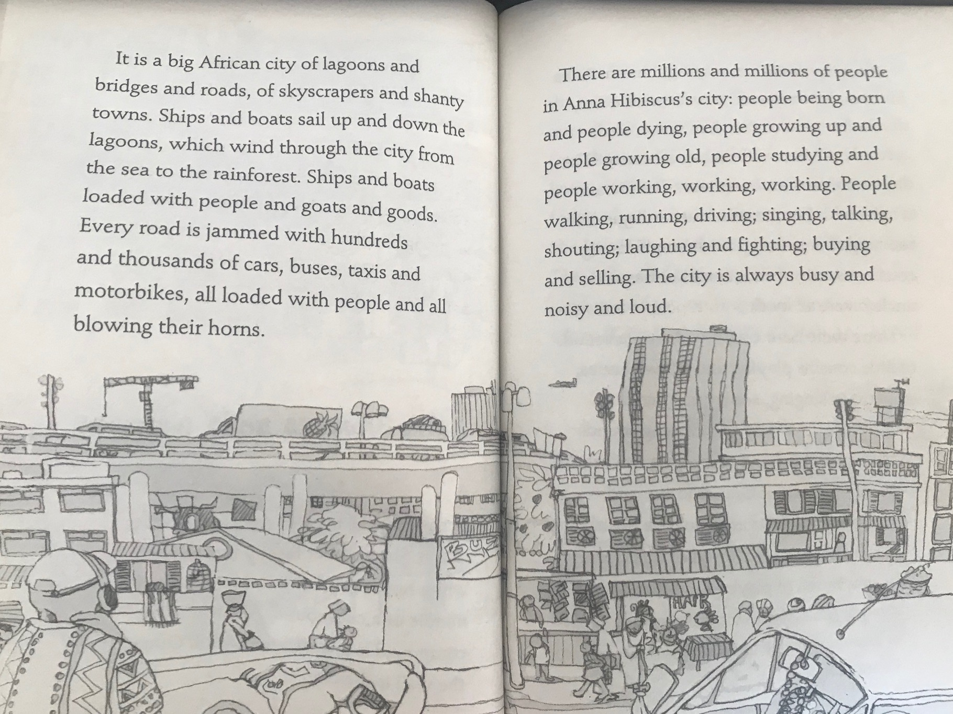
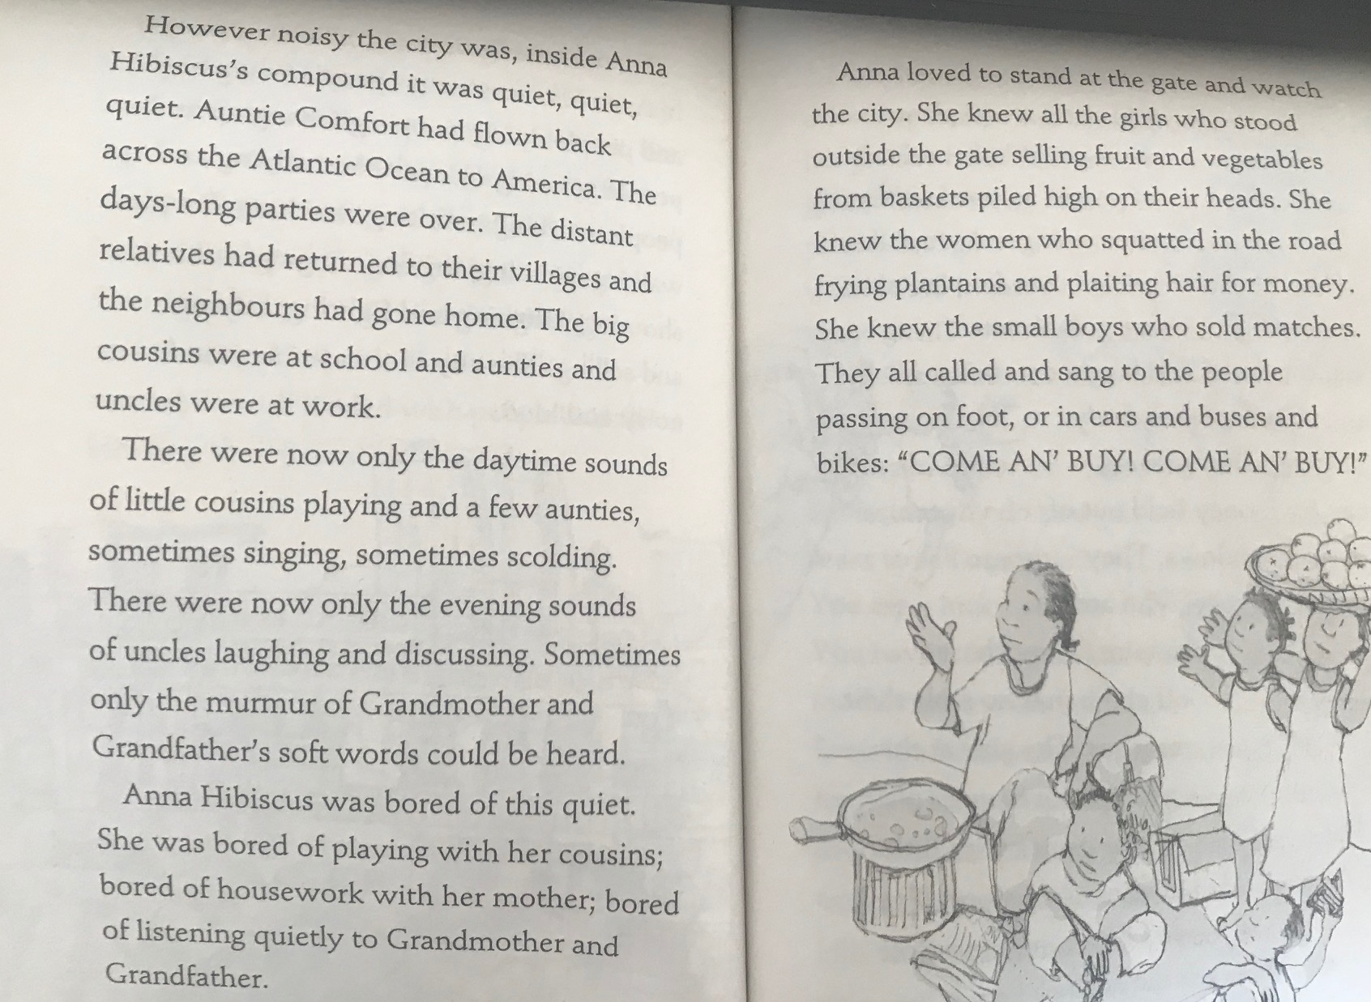
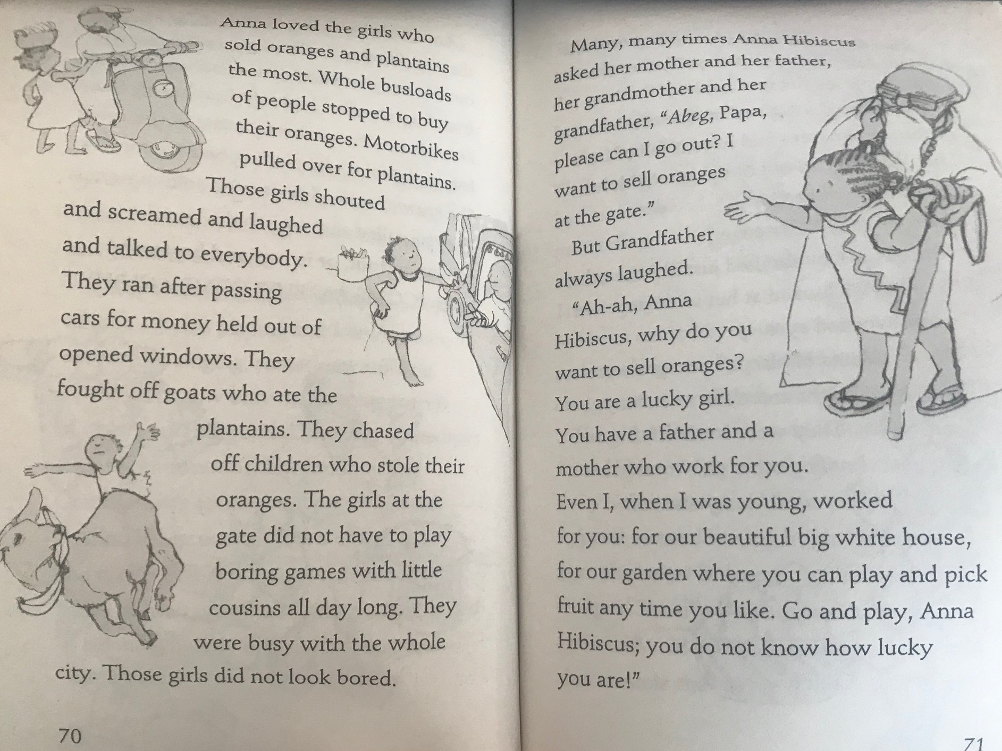

Answer these questions in your home learning book.
- Write down five verbs used to describe what people do in Anna’s city.
- Describe Anna’s city.
- Why was Anna bored?
- What things did the children sell?
- Anna was feeling jealous of the girls. Why?
- Why does Grandfather say Anna is lucky>?
- What do you think Anna will do next?

