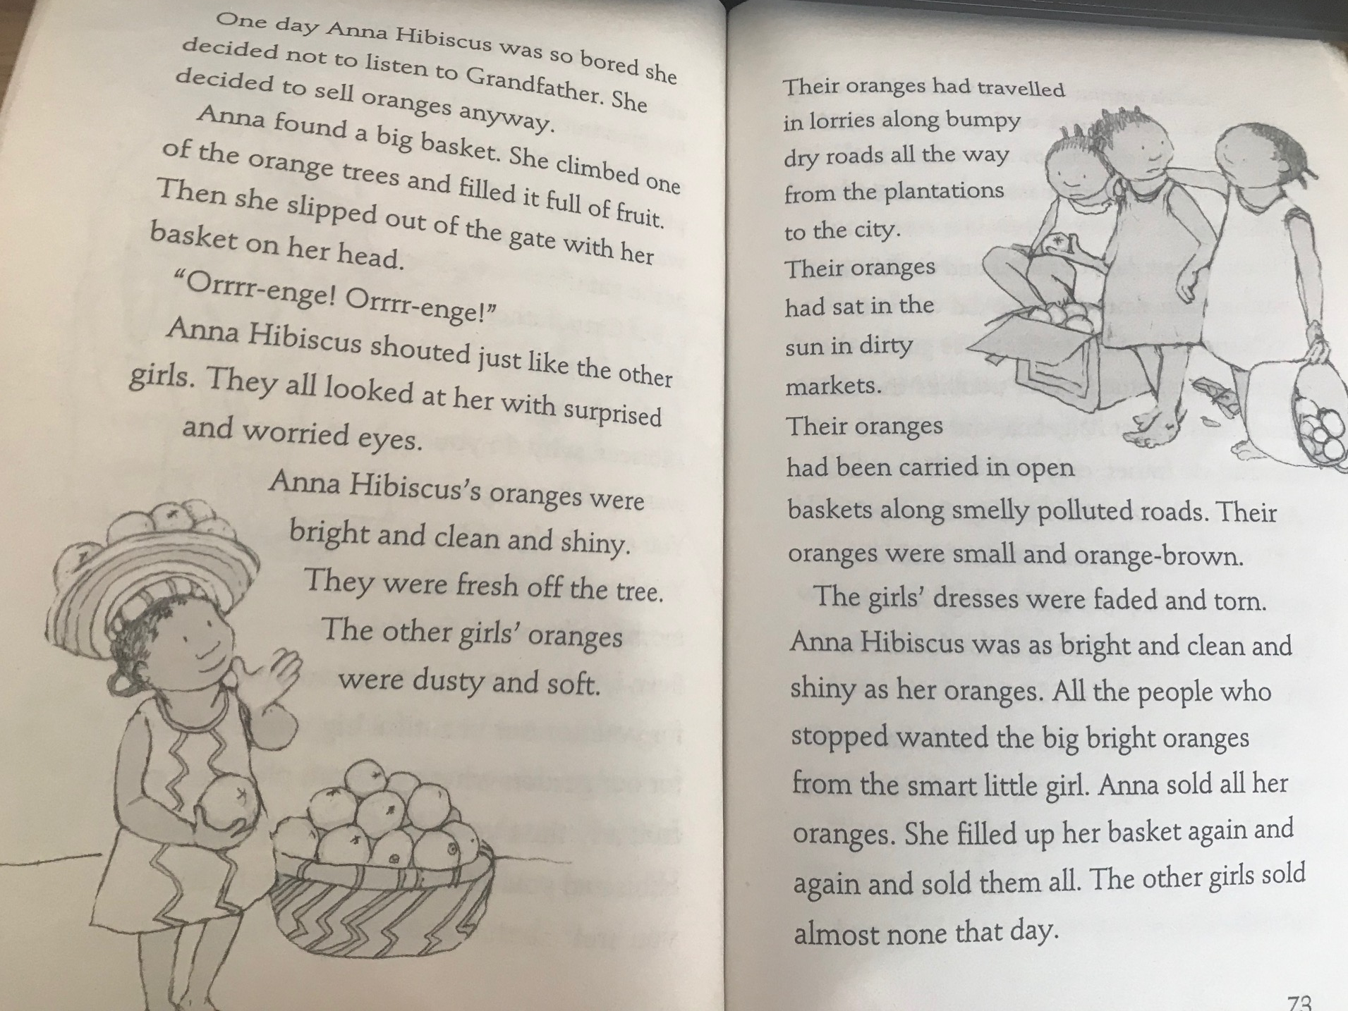
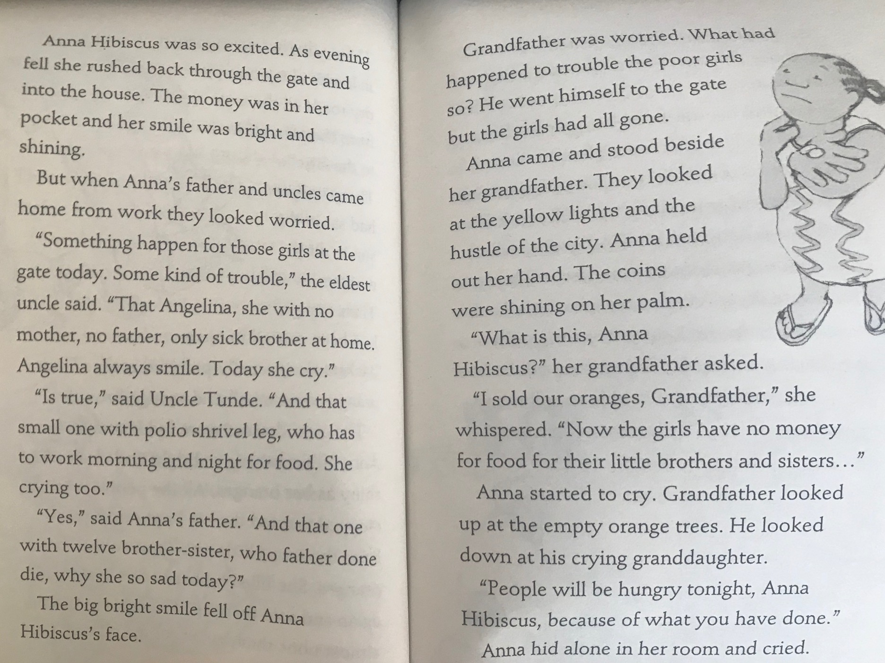
Write a letter from one of the girls on the day they didn’t sell any oranges to someone in their family. What happened? Are they upset? Why? How do they feel about Anna? Write on this sheet or in your Home Learning Book.
Dear ____________________,
_________________________________________________________________________________________________________________________________________________________________________________________________________________________________________________________________________________________________________________________________________________________________________________________________________________________________________________________________________________________________________________

