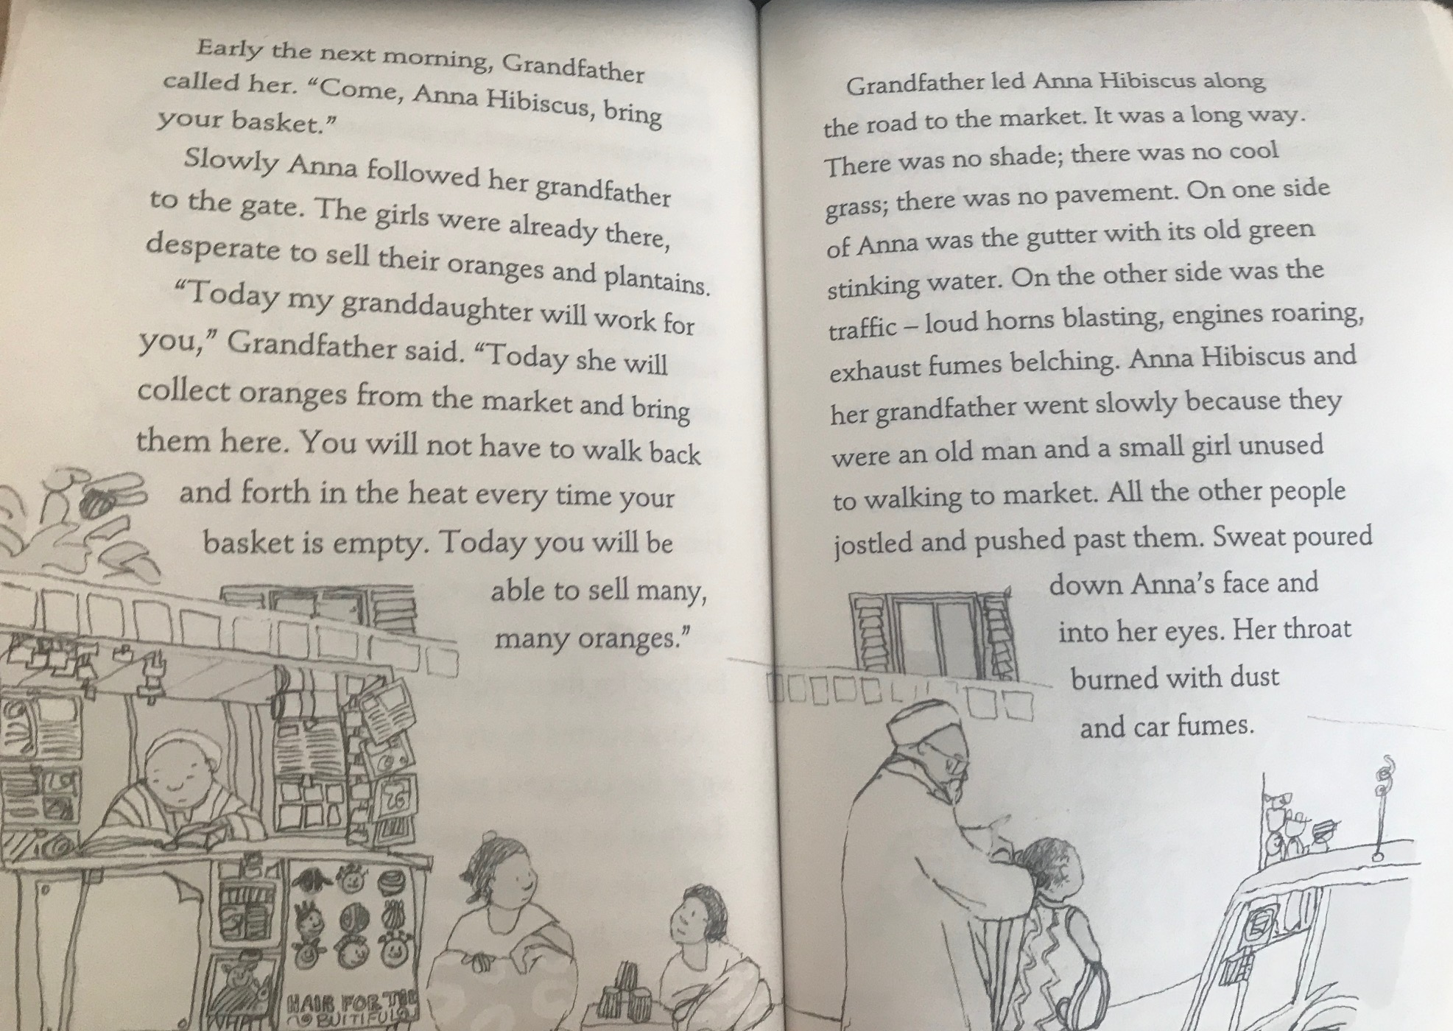
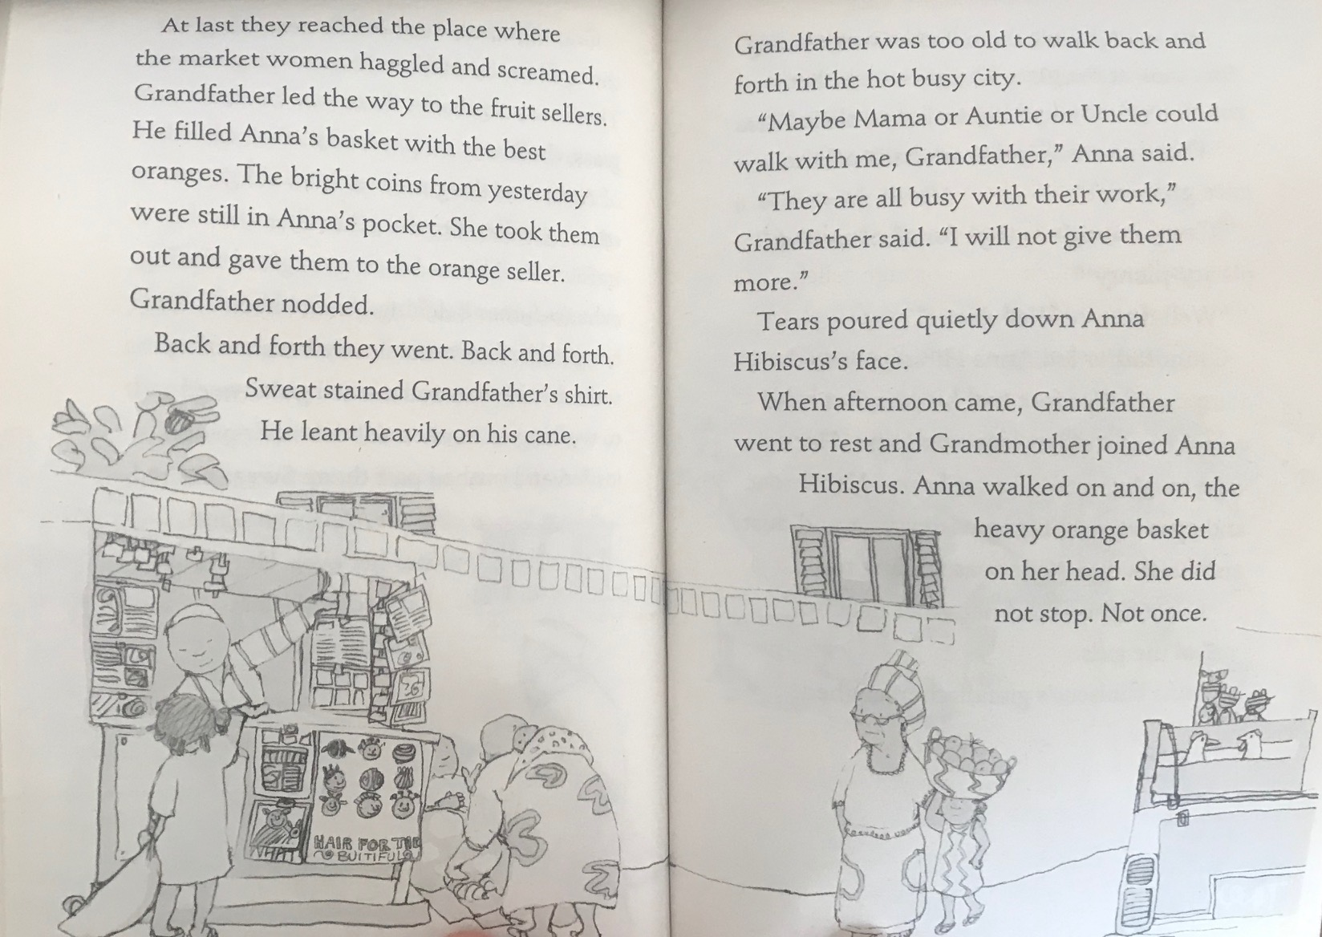
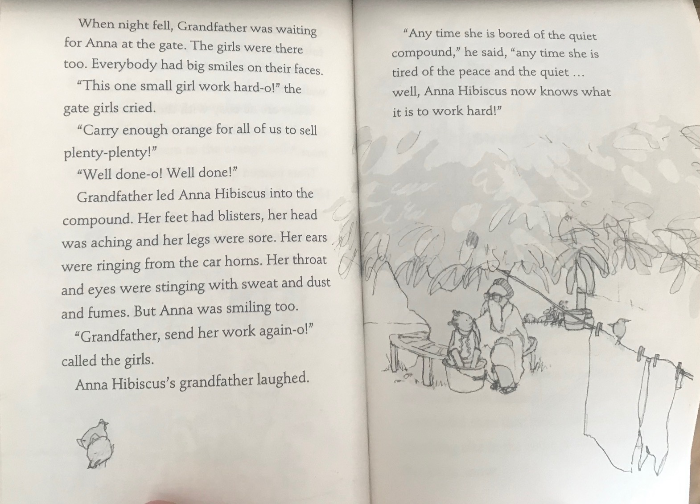

Answer these questions in your home learning book.
- Make a poster advertising Anna’s oranges.
- What is Grandfather’s plan?
- What was the walk to market like? Did Anna enjoy it? Why?
- Why did Anna use her money to buy the oranges?
- Did Anna enjoy her day? Explain your answer.
- What lesson was Grandfather trying to teach Anna?
- Did you enjoy this story? Why? Why not?

