Patterns with sticks!
Pencils and pens can help you with your maths! Twigs and sticks are superb natural materials for exploring patterns. You can use any objects you have at home to help you make the patterns. If not draw them out to help you.

For example:
Shape 1 = 4 sticks
Shape 2 = 7 sticks
Shape 3 = 10 sticks
Following this logic, can you work out how many sticks would be needed for Shape 10 (a shape with ten square rectangles joined together)? Can you find a rule?
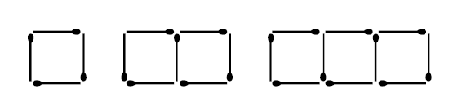
Can you work out how many sticks would be needed for the next set of 4 houses.
What about 6 houses?
What about 15 houses?
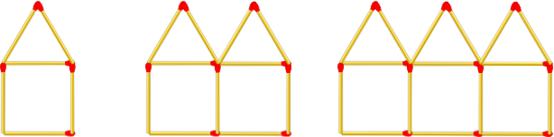

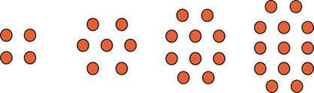
How many stones would be in the next pattern?
What about the 8th pattern?
What about the 12th pattern?

Can you make your own pattern and predict the amount in the 10th shape and 15th shape?

