Our daily prayers in Nursery are:

Morning:

Dear Jesus
Help me to enjoy today
To have fun and play
To share toys and jokes
To love my family and friends
And to be happy
Amen

Evening (to the tune of Twinkle, Twinkle):

God Our Father I come to say
Thank you for your love today
Thank you for my family
And all the friends you give to me
Guard me in the dark of night
And in the morning send your light.
Amen

Ongoing activities:

Make playdough with your children, a link to a recipe is below:
https://www.familyeducation.com/fun/playdough/play-doh-recipes
Ideas for play are:
- Use the dough to have a tea party with dolls and soft toys
- Make cakes! If you have any birthday candles the children could use these as well as beads, buttons or any other small items you have indoors to decorate them
- Roll into long sausage shapes and encourage the children to use scissors to cut the sausages up!
- Use blunt kitchen knives to cut out different shapes

Make a den:

Use blankets, pillows, cushions and bedding to make a den either between chairs or under a table. Encourage the children to use their den to play with their toys, read books, draw pictures or watch an iPad for a short time

Make coloured rice:

Using a small amount of rice, put it into a bowl with some food colouring, bake in the oven on a low temperature using a baking sheet for short time.
Ideas for play are:
- Use it in small world play, put it on a tray and put dinosaurs, cars or even Princesses in it!
- Have a tea party, pouring from a tea pot or jug into cups or bowls
- Cook with it! Get saucepans or frying pans and some wooden spoons and get cooking!

Physical:
Practice putting on own clothes and getting undressed independently
Discuss good hygiene, washing hands, brushing teeth, using the toilet independently.
Dance along and sing: https://www.youtube.com/watch?v=29TR33moqUA
Have a daily disco!
Dance to music for 15 minutes each day
Relaxing session: https://www.youtube.com/channel/UC5uIZ2KOZZeQDQo_Gsi_qbQ
Get your heart rates up, suitable for the whole family! https://family.gonoodle.com/

Communication and Language and Literacy:
Reading every day, discuss story, characters, look at pictures and what you can see. Can the child guess what will happen? Can they retell the story?
Can they draw characters from different stories?
Sing nursery rhymes together. Encourage children to fill in missing words, sing songs back to you. Can they make up actions to the songs?
Watch Cbeebies Bedtime Stories:
https://www.youtube.com/watch?v=4KnfCoJPXDI&list=PLoOc9M0VgduON_PbVYOlgjeLPyN_0VHlk

Mathematics:
Number:
Count steps as you climb them, jumps on a trampoline, people at a bus stop.
Sing number songs e.g 1,2,3,4,5 once I caught a fish alive, and encourage children to count on their fingers as they sing
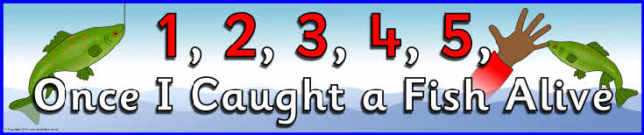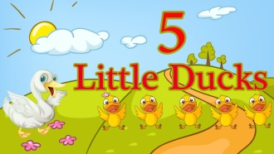
Read counting books together
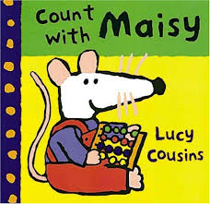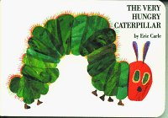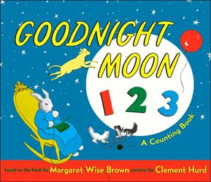
Encourage counting by asking questions such as:
- How many cups on the table?
- Can you give me three spoons?
- If I put one more apple in the basket how many will I have?
- If you take a banana how many will be left?
If your child is unsure encourage them to count with you and make sure they count one at a time.

Recognising numbers:
Point out numbers you see – on your front door, on birthday cards, on lift buttons, lockers, buses, trains or car number plates – anything that interests your child and is relevant to them.
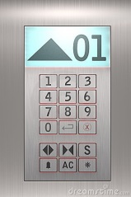

Play board games like snakes and ladders which use dice. Encourage children to count or recognise numbers on dice then move spaces or collect objects to match.
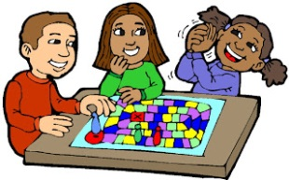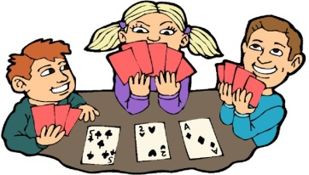

Comparing:

Sort building bricks, cars, dolls, cutlery (anything!) into large, small and medium sized
Order cuddly toys from smallest to largest.
Compare shoes – who has the widest, narrowest, longest, shortest?
When you’re shopping see which vegetables are the heaviest, lightest, biggest, smallest?
Work out who is the tallest and shortest in the family?
At dinner time check whose cup is full or empty? Which plate has the most or the least?

Shape:
Look for shapes and patterns in pictures when reading stories and in the environment e.g square windows, triangle road signs, stripes on the zebra crossing, spotty wellies, zigzag markings on the road.
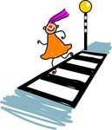
Talk about shapes – can the children name them? Can they describe them? Which shapes are good for different purposes e.g building towers or rolling?

Position:
Talk to children about where objects are and encourage them to describe where things are.
e.g the sun is behind the cloud, the cat is on the sofa, the shoes are under the bed.
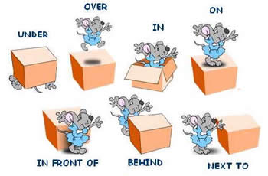

Understanding the World
If you are able to go out for walks encourage the children to look for signs of Spring. What changes can they see? Can they see any buds growing on trees or plants? Point out blossom on trees, use vocabulary such as bud, shoots, branches etc

