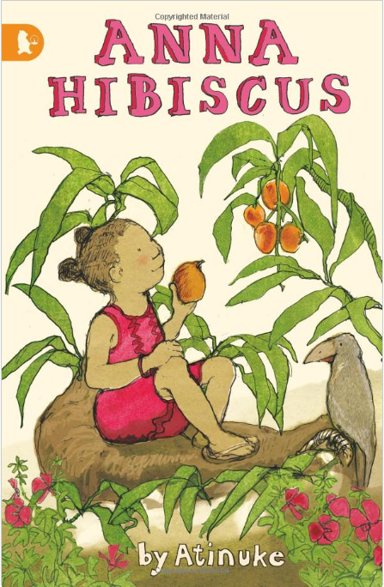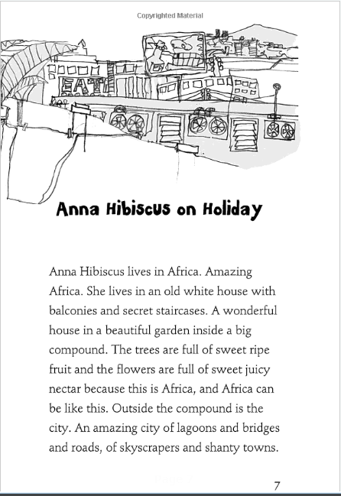
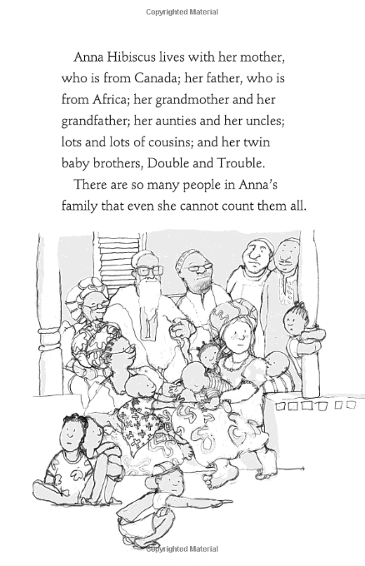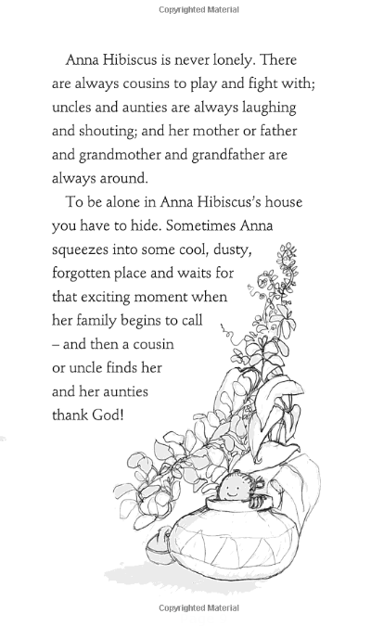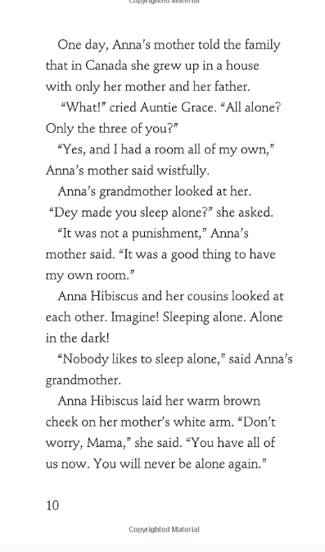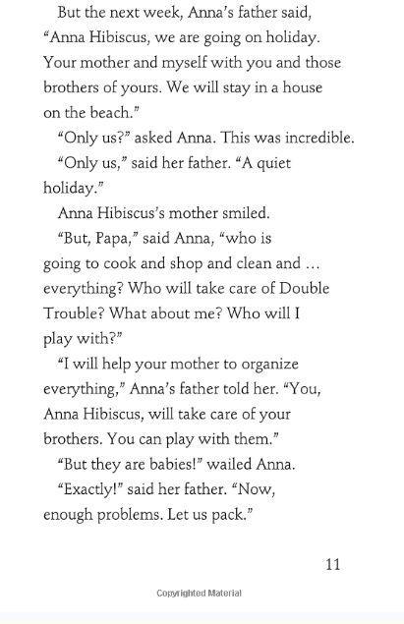
Questions:
- Where does Anna live? Use adjectives in your answer.
- Who does Anna live with?
- Do you think Anna’s mum liked sleeping in a room all on her own? How do you know?
- Would you like a room on your own or to share with a brother or sister? Why?
- Is Anna looking forward to her holiday? Why?
- What is everybody’s job on holiday going to be?
- Describe your dream holiday!
- What is your favourite word from the story? Why?

