Year: 6
Week beginning: 30.03.2020

Work to be undertaken at home over the course of this week. Each day will consist of one English activity, one Maths activity and other tasks that should be completed during the week.

Teacher’s Instructions:
Bonjour Classe 6,
I hope you are all in good health and that this first week on isolation was not too hard and that you took this opportunity to enjoy spending time with your loved ones.
First of all I would like to thank you all for your lovely messages which Mrs Tullett kindly forwarded to me, it really touched me!
I hope that you are all accessing the work set for you and that you are not finding this too hard.
This week in Maths I would like you to concentrate on Algebra. Remember what I said to you in class, you have been doing this for a long time without realizing it so don’t panic and read the questions carefully.
In English I would like you to check out free audiobooks using the following link:
https://stories.audible.com/start-listen David Walliams is also releasing a free reading of his audiobook on a daily basis; it might be worth checking it out too.
Have fun with your writing, I’m sure you’ll enjoy this as well.
So try your best and don’t forget to check your emails and keep me updated!
Keep safe!
Miss Honore.

Monday | Maths | Find a rule One Step / Find a rule Two Step- Worksheets Step 1 and Step 2  Revise your times tables.  Redo 10 arithmetic questions from previous tests
 | English | Reading: Read for 30 minutes and do one activity from the ‘Reading Journal Activities’ in your green book.  Writing:  If you could be any animal on earth what would it be and why?  Explain in a couple of paragraphs using facts to justify your answer! (you might need to research this animal in more details)
 | Physical Activity | Joe Wickes 9am on You Tube  or  Put the radio on and show off your best moves!
Tuesday | Maths | Forming Expression - Worksheet Step 3  Revise your times tables.  Redo 10 arithmetic questions from previous tests
 | English | Reading: Read for 30 minutes and do one activity from the ‘Reading Journal Activities’ in your green book.  Writing: Plan a story as YOU being this animal. Create a story map. WARNING: Do not make your story too complicated; limit your story to 3 main characters and ONE main plot.
 | Physical Activity | Joe Wickes 9am on You Tube  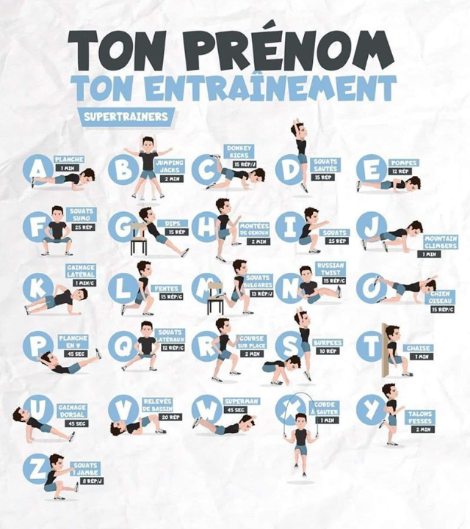  Try spelling your name…
Wednesday | Maths | Substitution- Worksheet Step 4  Revise your times tables.  Redo 10 arithmetic questions from previous tests
 | English | Reading: Read for 30 minutes and do one activity from the ‘Reading Journal Activities’ in your green book.  Writing: Write the first draft of the story.
 | Physical Activity | Joe Wickes 9am on You Tube  Or any of the previous activities….
Thursday | Maths | Formulae - Worksheet Step 5  Revise your times tables.  Redo 10 arithmetic questions from previous tests
 | English | Reading: Read for 30 minutes and do one activity from the ‘Reading Journal Activities’ in your green book.  Writing; Finish and edit your story, think about the NON-NEGOTIABLES!
 | Physical Activity | Joe Wickes 9am on You Tube  Or any of the previous activities….
Friday | Maths | Forming Equation- Worksheet Step 6  Revise your times tables.  Redo 10 arithmetic questions from previous tests
 | English | Reading: Read for 30 minutes and do one activity from the ‘Reading Journal Activities’ in your green book.  Writing: Create a comic book based on your story. You can use your green book, or make your own book using paper or use powerpoint.  Your comic book should have PICTURES, SPEECH BUBBLES and a short narrative for each page.
 | Physical Activity | Joe Wickes 9am on You Tube  Or any of the previous activities….

RE: | This week as we are approaching Easter, I would like you to think of the Stations of the Cross.  - How many are they altogether?  - How many can you remember?  - Choose ONE of the two activities from the sheet to do.  Or if you cannot print the documents, you can draw your own pictures in your green book and explain what each picture represent.  - Write a prayer thanking God for sending Jesus to us and sacrificing himself for us.
Foundation Subjects | Cook with your family, play a game together, draw a picture, create a model or anything else artistic you fancy… Please take pictures and record in your green book.  SUGGESTION: Create a rainbow using anything you like and display it on your window!
Don’t forget your Purple Mash activities and check out free websites you can use….

