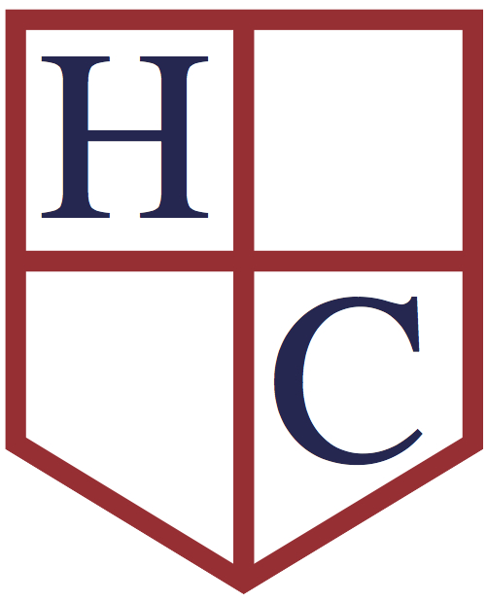
Year: 2
Week beginning: 18th May 2020

Work to be undertaken at home over the course of this week. Each day will consist of one English activity, one Maths activity and other tasks that should be completed during the week.

Teacher’s Instructions:
Hello Year 2! We hope you have had a good week. Thank you for the wonderful book reviews you have sent. It is great to see so many of you are enjoying reading and discovering new books and authors. Have you checked your emails to see each other’s reviews and also Winnie and Fletch’s book reviews? There is still time to send your reviews if you have not yet done it. Please, please, please keep reading at home! You all did so well with reading in the Spring term so keep going!

Mrs Mole and I are also enjoying speaking to you each week. It is great to hear what exciting things you have been up too. It sounds like you are all keeping busy, playing, exercising and doing your school work, so well done! Keep it up you are doing brilliantly and we are very proud of you all.

Remember to do what you can! You do not need to complete every single task or print anything out.

We are still enjoying receiving your emails and keeping in touch. Here are our email addresses:
smole4.209@lgflmail.org sparr52.209@lgflmail.org

This week we are looking at a lovely video for English and in Maths we will be focusing on Statistics. In RE we are thinking ahead to Pentecost, in Art we are going on a virtual gallery tour and in History we are looking at famous Victorians.

Have a great week everyone!
Keep in touch and stay safe,

Mrs Mole & Mrs Parr

Monday | Maths | Today we are going to be interpreting data. This means answering questions based on the information we see. Choose one of the 3 sheets to complete. Here is the statistics knowledge organiser to help you.
 | English | This week our English work is based around a short film called Bubbles. Watch the video here: https://www.literacyshed.com/bubbles.html Watch it a few times if you like! Now answer these questions in your Home Learning Book.  Use the Bubbles Knowledge Organiser to help you.  (If this link doesn’t work please google The Literacy Shed and you can find the ‘Bubbles’ video in the Fantasy Shed section.)
 | Physical Activity | Today you can practice different types of rolls. Which one is the easiest/the hardest?  You can use the Monday PE rolls sheets.
 | RE | We will be celebrating Pentecost on Sunday 31st May. Watch this PowerPoint and complete either the easier sheet or the harder sheet.
Tuesday | Maths | Today you are going to make your own ‘Pets’ bar graph from the information given. The sheets are differentiated so choose the level you want to do (1 star easiest, 3 stars hardest). The answers are also there for you to check your work.
 | English | Watch the video again https://www.literacyshed.com/bubbles.html.  Draw a story map of her adventure. Use the pictures on the Bubbles Knowledge Organiser to help you.
 | Physical Activity | Today use these pictures to practice other gymnastic actions. Can you link some moves with some rolls to make a sequence?
 | History | - Today we are going to think about Famous Victorians! Many people who, lived during this time are still famous today for different reasons, such as Mary Seacole, Florence Nightingale, Robert Peel, Charles Dickens, Mary Anning, John Cadbury, Isambard Kingdom Brunel and Alexander Graham Bell.  Choose one person (from the list above or your own research online) and make a fact file, explaining why they are famous.  This website may also be useful: https://primaryfacts.com/famous-victorians/
Wednesday | Maths | Complete the ‘Favourite fruit tally and pictogram Maths challenge cards.’ The answers are at the bottom of the page so you can check your work.
 | English | Think about the girl’s adventure. Was it a fun adventure? Where would you like to go on a bubble? Why? Can you explain using different conjunctions? Underline each one that you use. You can start like this if you like:  I would like to go to ________________ because…..  Use the Bubbles Knowledge Organiser to help you.
 | Physical Activity | Practise different jumps today. Can you make a sequence out of rolls, jumps and actions? Practice and repeat. What is your starting position? What is your end position? Perform to a family member or video and send to us!
 | Art | Visit The Tate Gallery online! Follow this link https://www.tate.org.uk/visit/tate-britain/display/turner-collection to look through the Turner galleries and see his different works of art. Also look carefully for paintings by John Constable. Which paintings do you like? Can you choose one to recreate? You can use a simple writing pencil to sketch, colouring pencils or even pastels or paints if you have any at home. Remember to email your masterpieces for us to enjoy!
Thursday | Maths | Today you are going to interpret pictograms when the data represents 2,5,10. Remember to read the questions carefully. Answer as many cards as you can. Here are the answers so you can check your work.
 | English | Think about the end of the video. The new little girl picks up the bubbles and starts her own adventure. Where does she go? Write the next chapter. Draw pictures too. Remember to use lots of words to explain how she is feeling. Use the words on the Bubbles Knowledge Organiser to help you.
 | Physical Activity | Watch the video ‘obstacle challenge.’ To carry out this activity you will need to build an obstacle course in your lounge or garden. You will then need to work with another person. Take it in turns to wear the blindfold and guide each other around the course. Think carefully about the instructions you give to make sure your partner is safe.
 | Science | In Science this week we are looking at the basic needs of animals, including humans. Watch this video to help you then complete the basic needs sheet. Next, choose an animal from the pet care fact sheets and from the information make your own Pet fact file.
Friday | Maths | To complete the Maths activity today you will need a tube of Smarties! Use the Smarties and follow the instructions on the sheet to make your own Smarties tally chart and bar chart. Finish your Maths and then eat your Smarties!
 | English | Your last challenge of the week is to think about how you can change the story. What object could you find on the beach? What might happen when you pick it up? Write this story in your Home Learning Book. Remember the story needs to have a beginning, a middle and an end. How many words can you use from the Bubble Knowledge Organiser? Can you add in your own exciting vocabulary?
 | Physical Activity | Do a Cosmic yoga session.  https://www.youtube.com/user/CosmicKidsYoga

