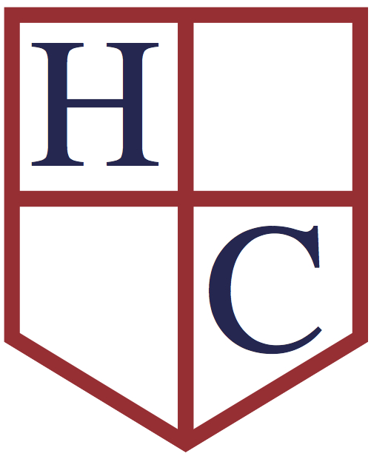
Year: 6
Week beginning: 18.05.2020

Work to be undertaken at home over the course of this week. Each day will consist of one English activity, one Maths activity and other tasks that should be completed during the week.

Teacher’s Instructions:
Bonjour Classe 6,
Last week before half term! Hope that you are keeping up with the safety measures from the government and that you are still managing to keep well.

Before I tell you the programme for this week, I would like to remind you of a couple of things:
- The writing tasks sheet, I hope that you are managing to do them in your own time.
- Fill in your questionnaire if you haven’t done so yet and email me the answers as soon as possible!
I hope you have enjoyed reading few of the stories from last week. If you still want to use this website for this week’s reading, please feel free to do so or use your own reading materials.
For Maths we are concentrating on angles this week. Remember all the facts that you have learnt about those over the years, look at the tips and if you get stuck let me know!
I should also apologise as quite a few of you noticed that the link from last Monday did not work. I have now fixed it and you should be able to access it (see Monday - English on the timetable) .Well done for all of you who pointed this out! Take this opportunity to check last Monday’s task and see if you can now complete it. If you have already done so, take this opportunity to do one of the writing tasks from the list I gave you a couple of weeks ago.
For our topic on Benin, you will learn what ordinary people used to do for jobs in the Kingdom of Benin. On Friday, the writing activity is not related to Benin, but I hope you will enjoy it! Make sure you complete your RE work and don’t forget to check out the suggested activity, this week is COOKING!
Have a good week and make sure that you stay safe!
Miss Honoré

Monday | Maths | Measure with a protractor – Worksheet Step 1  Warning: If you DO NOT have a protractor then you cannot do the questions ‘True or False’ but everything you should be able to do by looking at the angles.  Revise your times tables.  Redo 10 arithmetic questions from previous tests
 | English | Reading: Read for 30 minutes and do one activity from the ‘Reading Journal Activities’ in your green book.  https://storyweaver.org.in/stories?sort=Relevance  Spellings: Test 10 words from the list and spellings given since the beginning of the year.  Writing: Watch the video from the following link:  https://www.bbc.co.uk/teach/class-clips-video/history-ks2-the-story-of-the-benin-bronzes/zb79wty  Take this opportunity to do one of the writing tasks from the list!
 | Physical Activity | Joe Wickes 9am on You Tube  or any other physical activities that you enjoy!
Tuesday | Maths | Introduce angles- Worksheet Step 2  Revise your times tables.  Redo 10 arithmetic questions from previous tests
 | English | Reading: Read the information from the following website:  http://africa.mrdonn.org/benin.html  Spellings: Test 10 words from the list and spellings given since the beginning of the year.  Writing:  - See ‘Benin – Off to Work We Go’ - Activity 1 (look up online or using a dictionary the trades you are not too sure about)  - Choose one of the trades from the list and make a job advert, detailing the requirements of the job, what kind of person would be suitable and adding a picture to go with it. Try to find out more information by conducting online research.
 | Physical Activity | Joe Wickes 9am on You Tube  Or any other physical activities that you enjoy!
Wednesday | Maths | Calculate angles- Worksheet Step 3  TIPS:  The total of the angles in a circle (or around a point) is 360 degrees.  The opposite angles are the same size  Revise your times tables.  Redo 10 arithmetic questions from previous tests
 | English | Reading: Read for 30 minutes and do one activity from the ‘Reading Journal Activities’ in your green book.  https://storyweaver.org.in/stories?sort=Relevance  Spellings: Test 10 words from the list and spellings given since the beginning of the year.  Writing: See ‘Benin –Off to Work We Go’ – Activity 2
 | Physical Activity | Joe Wickes 9am on You Tube  Or any other physical activities that you enjoy!
Thursday | Maths | Vertically opposite angles – Worksheet Step 4  Same TIPS as yesterday  Revise your times tables.  Redo 10 arithmetic questions from previous tests
 | English | Reading: Read for 30 minutes and do one activity from the ‘Reading Journal Activities’ in your green book.  https://storyweaver.org.in/stories?sort=Relevance  Spellings: Test 10 words from the list and spellings given since the beginning of the year.  Writing: Look at the list of specialized professions from yesterday. Which ones (up to TWO) would you have chosen to do. Explain and convince me why these would have been the best professions to do by giving me evidence.
 | Physical Activity | Joe Wickes 9am on You Tube  Or any other physical activities that you enjoy!
Friday | Maths | Angles in a Triangle – Worksheet Step 5  TIP: All the angles in a triangle add up to 180 degrees  Revise your times tables.  Redo 10 arithmetic questions from previous tests
 | English | Reading: Read for 30 minutes and do one activity from the ‘Reading Journal Activities’ in your green book.  https://storyweaver.org.in/stories?sort=Relevance  Spellings: Test 10 words from the list and spellings given since the beginning of the year.  Writing: You are a teacher for the day and you have to teach a class.  What class would you choose?  What would your timetable look like?  What activities would you do?  Create and organise a timetable for the day. Include as much details as possible on the activities you would do for the day, you can also include resources you would use.
 | Physical Activity | Joe Wickes 9am on You Tube  Or any other physical activities that you enjoy!

RE: | This week we are going to start a new topic: ‘ The Work of the Apostles’  - What is a disciple?  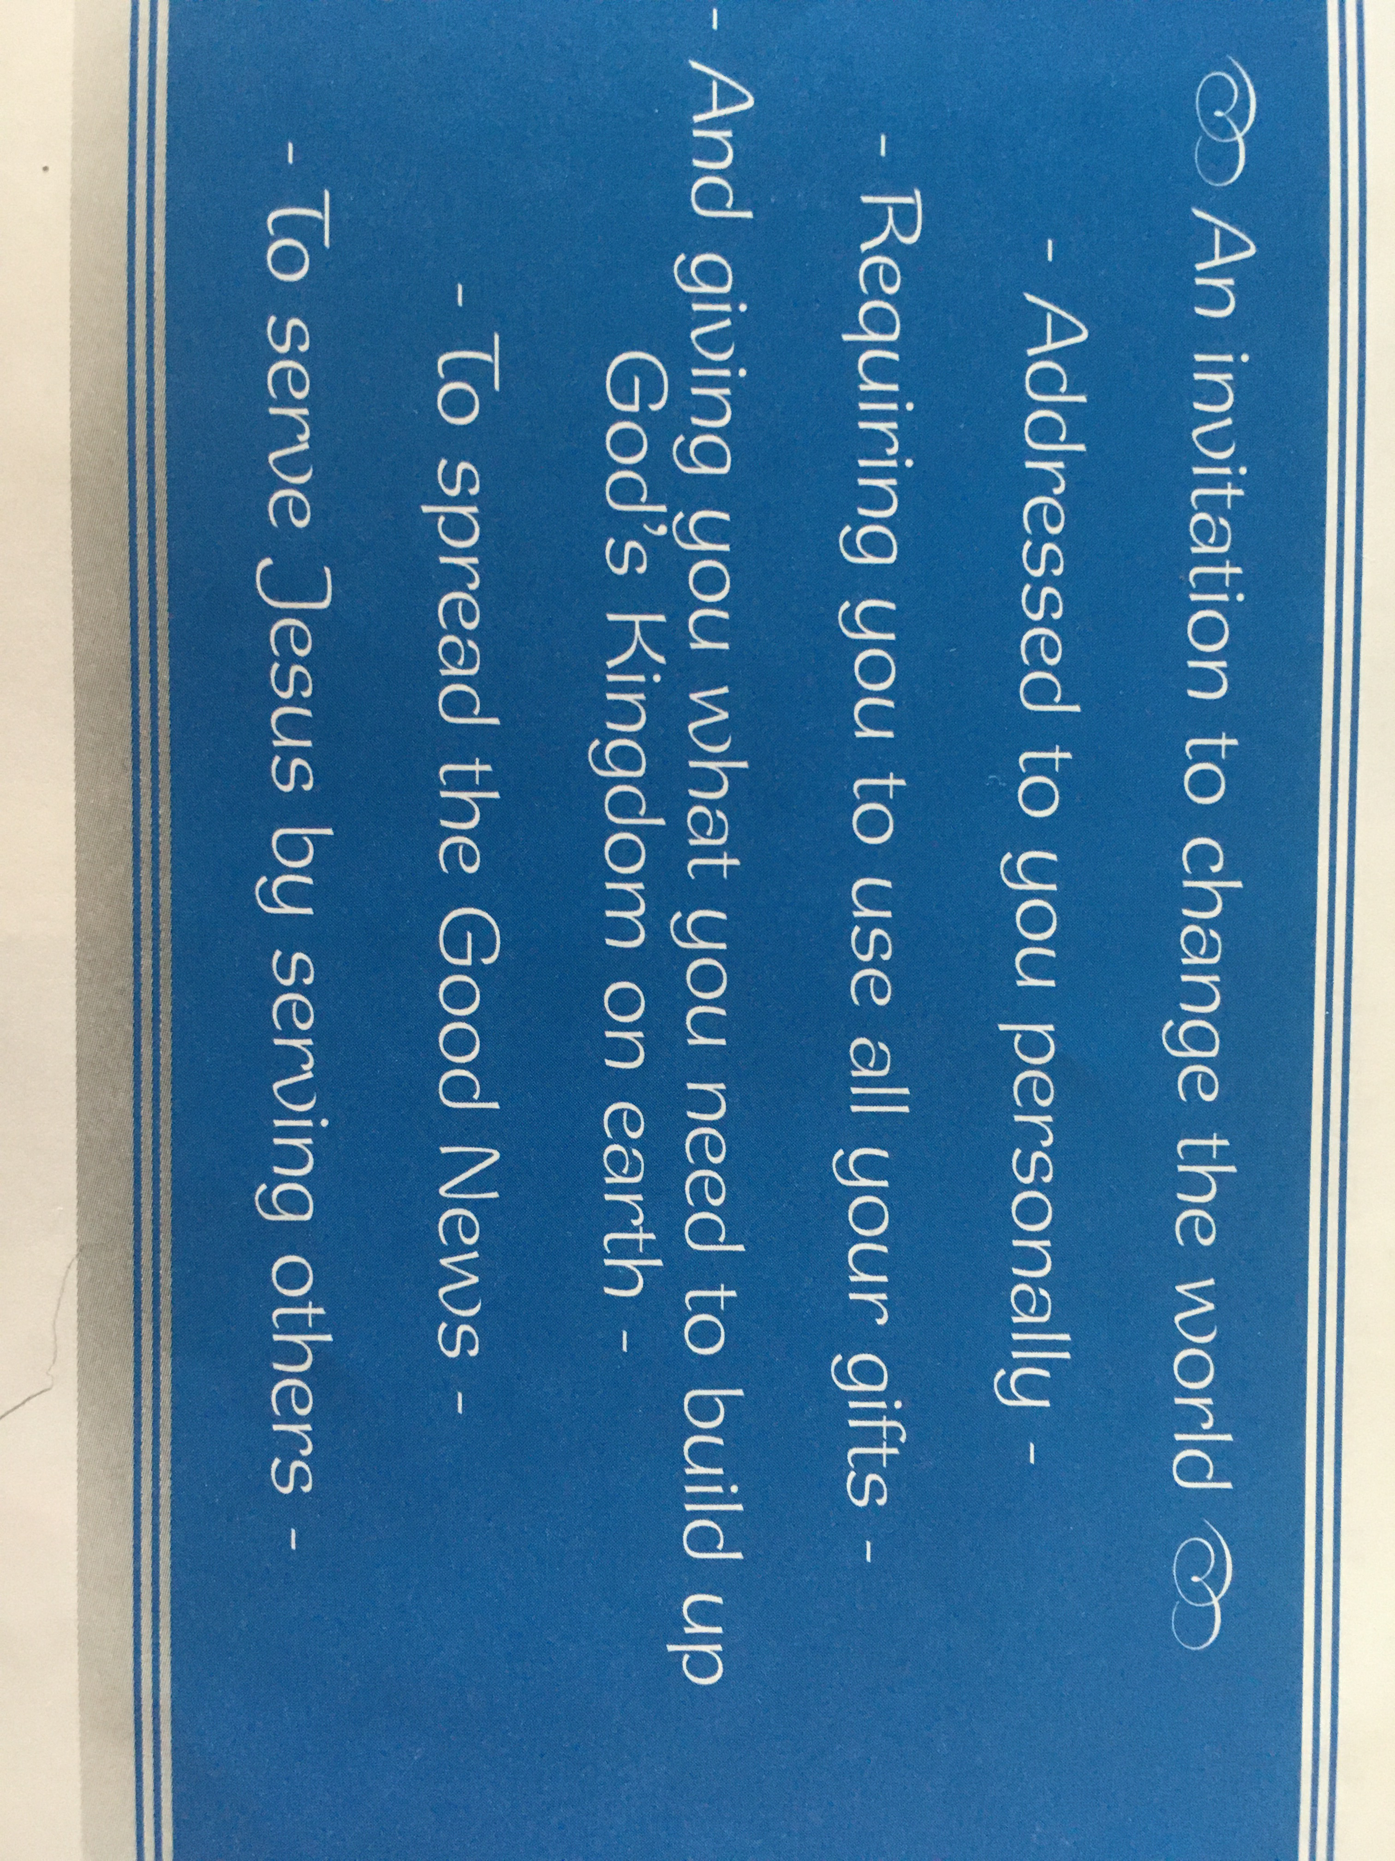  - Your invitation to be a disciple arrived early, even before you could read it. When do you think your invitation to be a disciple arrived?  - At Baptism we are each invited to be a disciple. With this invitation come the gifts we need in order to accept it. As we grow older and prepare for the Sacrament of Confirmation, we must consider the invitation for ourselves and what it is that Jesus is asking of us (see picture)  - Activity: Design a title page for your new topic with the title at the top. Underneath, draw or stick a picture of Jesus and a picture of you in the middle. Put ‘thought bubbles’ around your picture and write in them what you can do to imitate Jesus.
Foundation Subjects | Cook with your family, play a game together, draw a picture, create a model or anything else artistic you fancy… Please take pictures and record in your green book.  SUGGESTION: COOKING  Try one of those Benin Kingdom Recipes  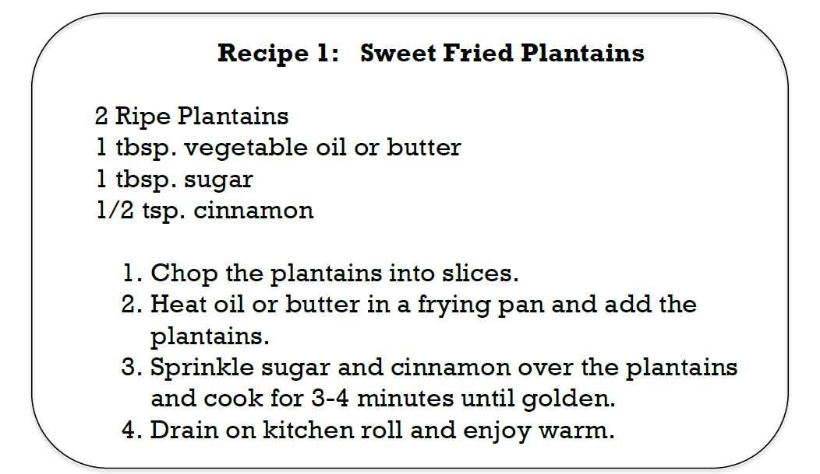  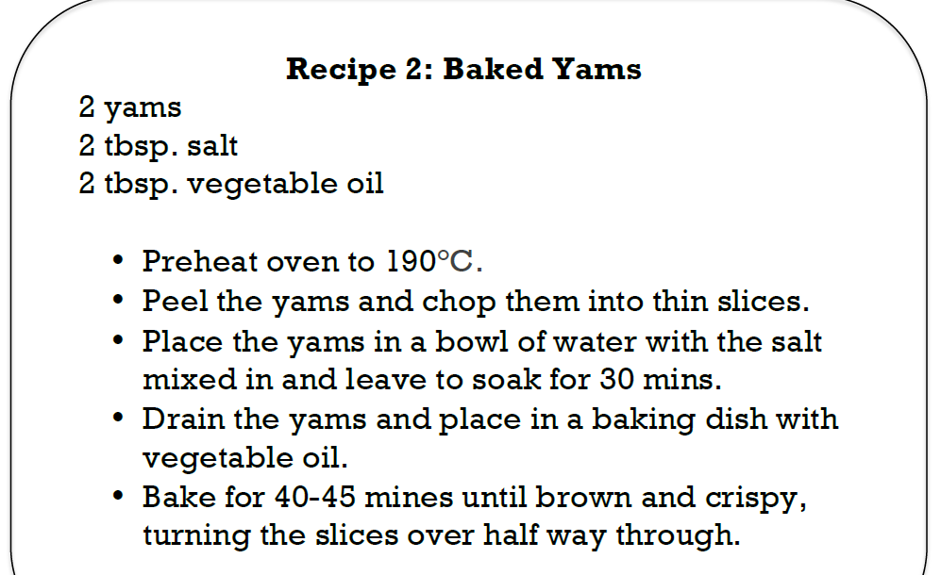  If you cannot find Yams then try to replace them with sweet potatoes.

Don’t forget your Purple Mash and Education City activities and check out free websites you can use….

