Off to Work We Go!
Activity 1: Tradespeople Match-up
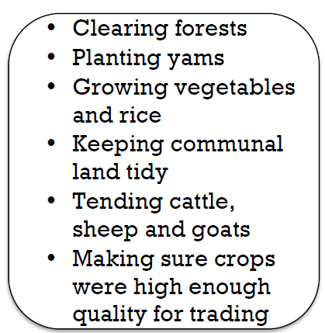
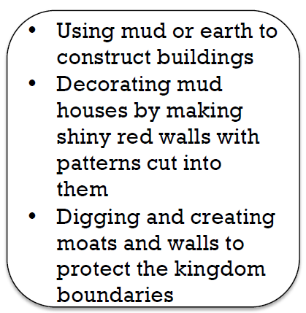
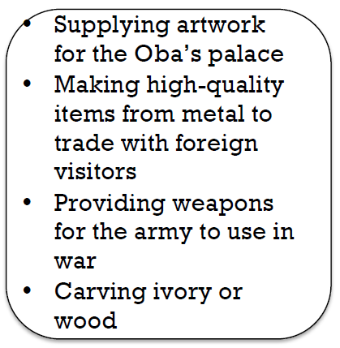
There were many different jobs for ordinary people in Benin Kingdom, and sometimes people would have two of three different jobs. Many of the tradespeople belonged to guild, which ensure that work was done to the highest standards.
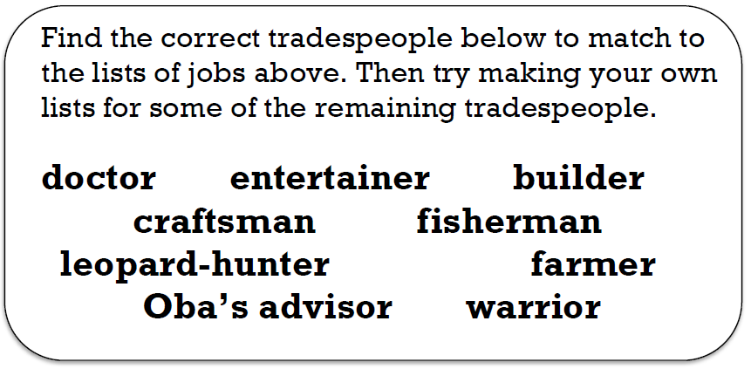
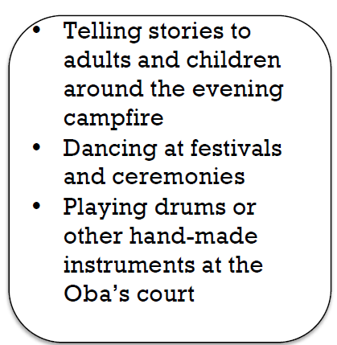

One of the reasons that Benin Kingdom flourished so well in the time of the Obas was because craftsmen worked to a high standard. The people of Benin had equally high standards when it came to trading with foreigners. Trading was highly valued and was never allowed to take place inside villages. Instead, an arrangement was made to meet foreign traders in a designated place. They would then negotiate for a very long time, often for many weeks. If foreign traders treated them unfairly, Benin traders would refuse to deal with traders from their country again until they had apoligised!
What goods do you think Benin traders might have had to offer foreign traders?

Activity 2: Comprehension questions

https://africa.mrdonn.org/benin.html
TIP: Before you answer any of the questions below you need to read the whole text carefully!!
- Who conquered Benin?
- Give TWO examples of form of art that Benin used.
- How did Benin people trade with foreigners? (At least one paragraph! Give as much details in your own words, including things they traded with foreigners)
- How could people get out of troubles? Does this surprise you? Why?
- What are specialised professions in Benin time? Give examples.
- What did Benin people believe? How did they celebrate?
- What is different from the kids’ lives in Benin time and our kids’ lives today?
- Create an explanation sheet on what a ‘Thumb piano’ is and how it works (try to use as much as possible your own words and include a picture)

