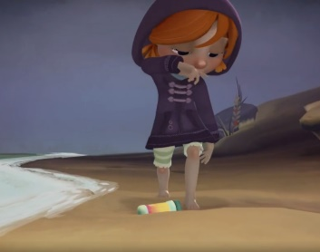Bubbles Knowledge Organiser

**Vocabulary**

beach bubble magical adventure girl amazed sky sea flew mysterious

fish stars planets

The story…

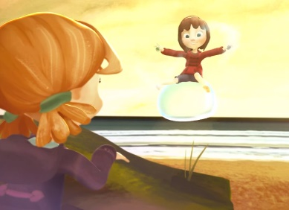

**Conjunctions**

and but because when so if then after later although

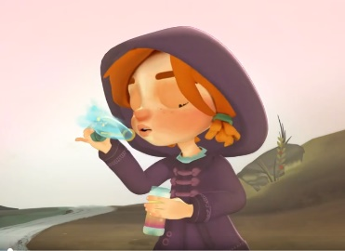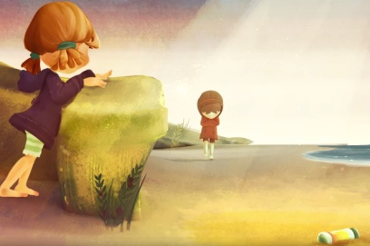

**Feelings**

happy delighted upset unhappy miserable confused

anxious worried terrified lonely curious bewildered

frightened elated excited

**Punctuation**

Full stops .

Capital letters ABC

Commas ,

Apostrophes ‘

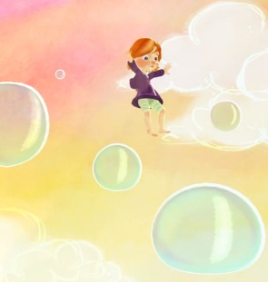

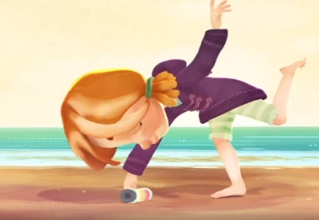

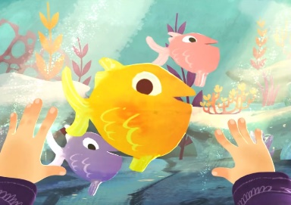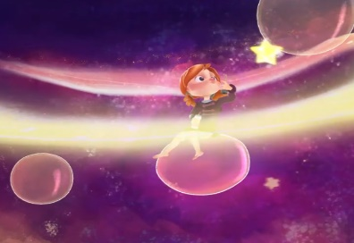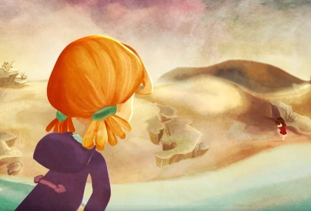

**Handwriting: a b c d e f g h i j k l m n o p q r s t u v w x y z**