Bubbles Comprehension Questions
Answer these questions in your Home Learning Book
- How is the little girl feeling at the beginning before she finds the bubbles? How do you know?
- How does the weather change when she blows the bubbles? Why do you think this is?
- Do you like blowing bubbles? Why?
- How did she feel when she first flew up on a bubble? Would you feel the same? Why?
- How did she use the bubbles to move around? Think about the different ways she does this.
- Where does she go on the bubbles?
- Which bit do you think is the most exciting part?
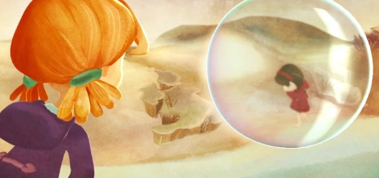
- What does she see?

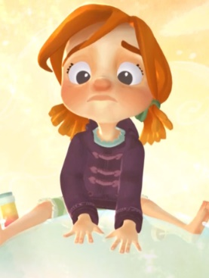
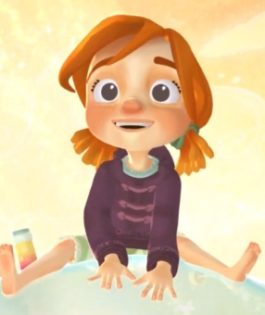
- Why does her expression (on her face) change so quickly
from this… to this….?

- Why does she end her adventure and give the bubbles to the girl in red?
- Was that hard to do? Why?
- Where might the girl in red go?

