Hooray for Fish!
Topic: Come Outside!
Week beginning: 15.6.20

Dear Nursery Class,

We hope that you are having lots of fun and even though the weather has been a bit more wet we hope that you have managed to spend sometime playing outside.

We are continuing on the sea theme this week with another book set under the sea! If possible, it would be lovely if you could visit the River Ravensbourne at Beckenham Place Park, don’t worry the water is not too deep but take your wellies and go for a wade!

If you haven’t already please also sign up to Oxford Owl which has some fantastic e-books for you to look at and for your grown ups to read to you: https://home.oxfordowl.co.uk/

Have a lovely week, and remember to stay in touch,
Love Mrs Mahony and Mrs Stoneham and all of the Nursery Team x

Communication and Language | - Read the story together or watch it on Youtube:  https://vimeo.com/52877670  - Can you say ‘splish, splash, splosh’? Why might you say ‘splish, splash. splosh? Can you think of any other words that mean the same? Do they start with the ‘S’ sound as well?
Physical Development | - Can you make up a sea creature dance? You could use some ribbons or material to help you. You could listen to sea music like this: https://www.youtube.com/watch?v=cC9r0jHF-Fw or you could choose your own music.  - Can you draw fish on a card board cereal box and carefully use scissors to cut them out?
Personal, Social and Emotional Development | - How would you feel if you meet all of those fish?  - Which fish did you like the best? Why?
Literacy | - Can you draw a picture of different creatures that live under the sea? Ask an adult to help you label it.  - Can try and write the word ‘fish’? What sound does it start with? Can you sound talk the word ‘fish’?
Mathematics | - Can you draw opposite fish? For example, a big and small fish, a happy and sad fish? Can you think of any other opposites?  - Can you make a number zigzag book? Fold some paper to make it zigzag z=and then draw 1 fish on the first page, 2 fishes on the second page, carry on until all of your pages have been used up. Can you write the number on the pages?  - Can you draw or paint fish with different patterns and designs on them? Can you use two colours to create repeating pattern?
Understanding the World | - If possible try and go for a walk along the Ravensbourne River in Beckenham Place Park. Take your wellies and splash in the water. Can you see any fish?  - Stand still and watch the water move around your wellies, why do you think the water is moving?
Expressive Art and Design | - Can you make a sea creature from recycled materials? You could use an empty plastic milk bottle and paint it or stick paper onto it. What will you call your sea creature?  - Listen to La Mer by Debussy: https://www.youtube.com/watch?v=hlR9rDJMEiQ. How does it make you feel? What instruments do you think were used?  - Look this painting by Hokusai called The Great Wave, how does it make you feel? Have you seen waves this large before?  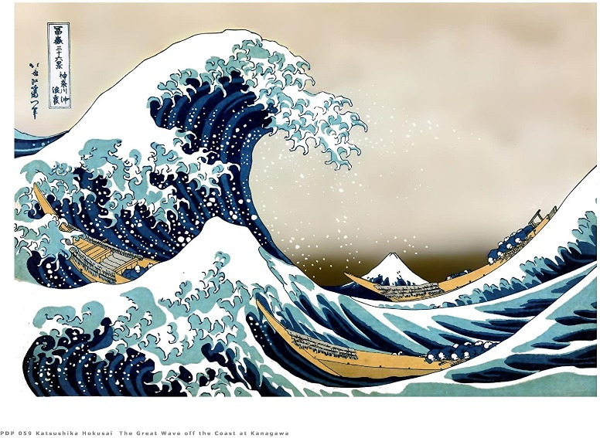  - Can you listen to La Mer and draw or paint your own version of The Great Wave?

